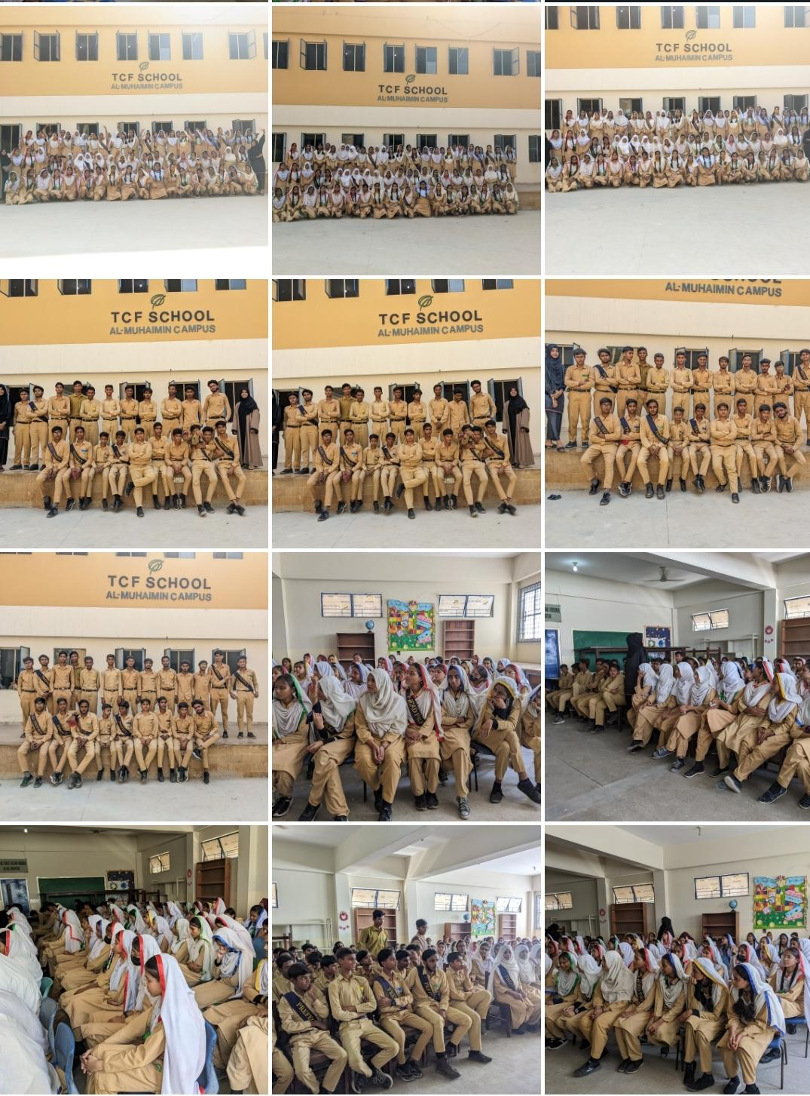

Alumni Pathways


TERTIARY SCHOLARSHIP PROGRAMME
  - Policy 2025

Tertiary Support Programme

Policy 2025

Issued by:
Alumni Pathways


Date of Issue: June 1, 2025
Effective Date: July 1, 2025
Revision History: 2018 and 2020

Confidentiality Notice:
This document contains confidential information intended for the internal use of
The Citizens Foundation (TCF) only. Unauthorized disclosure or distribution is prohibited.
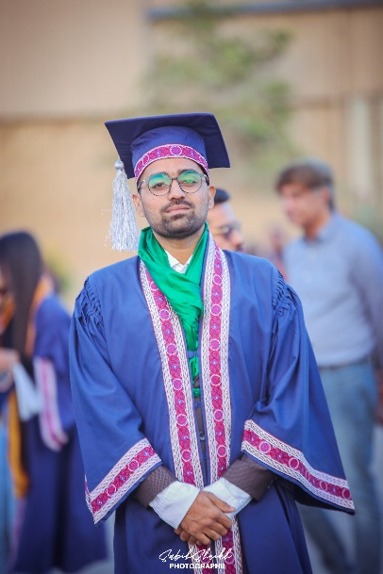  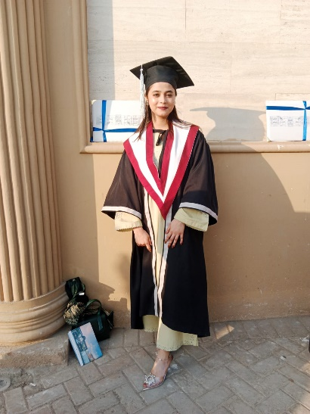  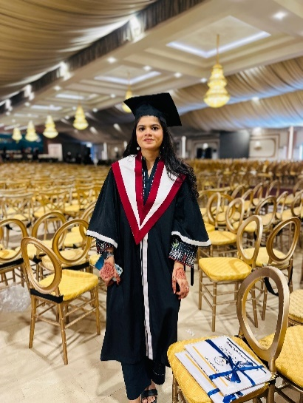  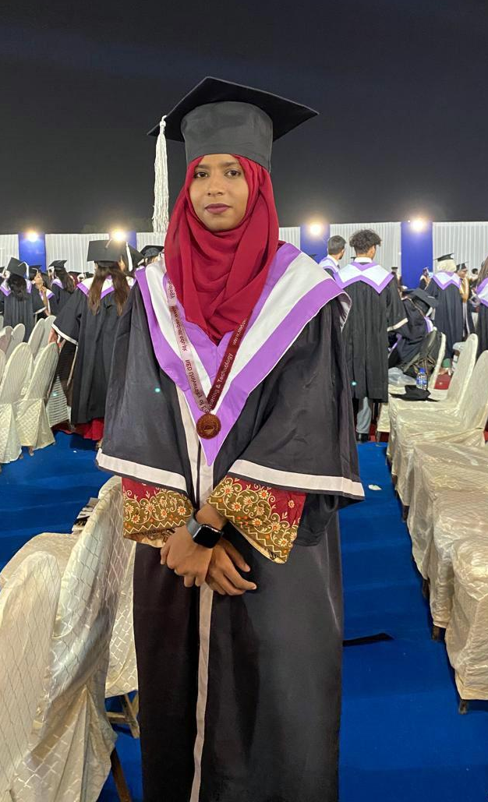 |  | At The Citizens Foundation (TCF), our mission has always been to provide quality education to children from underserved communities, empowering them to lead lives of dignity, purpose, and impact. While our focus has traditionally been on foundational schooling till Grade X-Matric, we recognize that true educational equity must extend beyond school. Supporting our TCF Alumni as they transition to higher education is essential to unlocking their full potential and enabling upward socioeconomic mobility.  The Tertiary Support Program (TSP) is a strategic initiative under TCF Alumni Pathways, designed to ensure that capable and deserving Alumni can access higher education without being held back by financial or systemic barriers.  The TSP Policy 2025 outlines the principles, processes, and support mechanisms that govern the program. It serves as a guiding framework for TCF Alumni, Alumni Pathways team, and School Leaders engaged with the program - ensuring fairness, consistency, and clarity in implementation. This policy has been developed with thoughtful input from university partners, industry and education experts, senior TCF alumni, and our program implementation team, ensuring that it is both contextually grounded and forward-looking.  We hope the TSP Policy will prove to be a transparent expression of TCF’s enduring commitment to the success and leadership of its Alumni. May it serve as a robust reference to assist all members of our community.  With belief in our Alumni’s potential to thrive,  Sincerely,  The TCF Alumni Pathways Team
  PREFACE

TABLE OF CONTENTS

- INTRODUCTION | 1-2
1.1 Purpose & Scope ………..……………………………….. | 1
1.2 Policy Over The Years ...................................... | 1
1.3 Scholarship Eligibility Criteria….…………………… | 1
- Policy Coverage | 2
1.5 Benefit for TCF Alumni …………………………………… | 2
- TERTIARY SCHOLARSHIP | 3-8
2.1 Tertiary Scholarship Process …….............................. | 3
2.2 Tertiary Scholarship Application……......................... | 3
2.2.1 Programme Selection……………............................... | 3
2.3 Scholarship Interview ……….………........................... | 3
2.3.1 Evaluation Criteria....................................................... | 3
2.3.2 Interview Preparation………………………………. | 3
2.3.3 Interview Schedule…………………………………... | 4
2.3.4 Scholarship Approval……………...………………… | 4
2.3.5 University Test Preparation (UTP)………………….. | 4
2.4 Scholarship Continuation & Withdrawal……………. | 4
2.4.1 Academic Requirements……………………………. | 4
2.4.2 Conduct & Compliance……………………...….….. | 4
2.4.3 Probation Policy…………..………………………... | 5
2.4.4 Scholarship Cancellation……………………………..  2.4.5 Key Cancellation Reasons…………….……………  2.4.6 Re-Admission………..……………………………..  2.5 Monitoring & Compliance…………………..……… | 5  7  8  8
2.4 Monitoring & Compliance …………………… | 6
2.5.1 Performance Tracking……………………………… | 8
2.5.2 Scholarship Termination Process…………………… | 8
- UNIVERSITY SELECTION & APPLICATION  - UNIVERSITY SELECTION & APPLICATION | 7-10  9-13
3.1 University Selection Process for Application................ | 7
3.2 University Application Attempt Limit………………... | 7
3.3 Academic Discipline, Group, and Programme Classification | 7
3.4 Tier Categorization ………………………………….. | 8
3.4.1 Tiers………………………………………….......… | 8
3.4.2 Premier League of Universities ………………….... | 8
3.4.3 Scholarship Preferences by Tier (All Programmes) | 9
3.4.4 Scholarship Preferences by Tier (MBBS, BDS & Nursing) | 9
3.4.5 Private vs. Public Universities within the Same Tier... | 10
- POLICY ON CHANGES IN DISCIPLINE, UNIVERSITY & LOCATION | 12-16
4.1 Change in Discipline or University Before Admission | 12
4.1.1 Admission in Non-Approved Disciplines…………… | 12
4.1.2 Request for Change in Approved Discipline ………. | 12
4.2 Change in Discipline or University After Admission ... | 12
4.2.1 Steps and Conditions for Changing University | 12
4.3 Repayment of Funds …………………………………... | 12
4.4 Cases with Higher Probability of Approval | 13
4.5 Cases with Lower Probability of Approval…………… | 13
4.6 Relocation for Higher Education (Changing Hometown) | 13
- HOSTEL AND MESS SUPPORT | 16
5.1 Eligibility Criteria……………………………………... | 16
5.2 Application & Approval Process……………………… | 16
- TRANSPORT SUPPORT | 17
6.1 Eligibility Criteria………………………….................. | 17
6.2 Application and Approval Procedure………………... | 17  20
- MISCELLANEOUS SUPPORT | 18
6.1 Eligibility Criteria………………………….................. | 18
6.2 Application and Approval Procedure………………... | 18

- TERMS OF SCHOLARSHIP | 20
8.1 Zakat Eligibility………………………….................. | 20
8.2 Qarz-e-Hasana………………………………………... | 20
8.2.1 Definition…….…………………………................... | 20
8.2.2 Repayment Policy………………….……………….. | 20
8.3 Student Contribution Policy ……………….................. | 20
8.3.1 Definition of Contribution ………...………………... | 20
8.3.2 Contribution Calculation Methodology ….................. | 20
- IMPORTANT NOTES | 21
9.1 Price Caps…………………………............................. | 21
9.2 Enrichment Courses During Scholarship.…………... | 21
9.3 Policy Review and Update Statement…….................. | 21
GLOSSARY | 22
ANNEXURE | 26
- TSP Grid & User Guide…………............................... | 27
- TSP Grid.…………...................................................... | 28
- Universities Covered in the Policy……....................... | 30
- Division of HEC Accreditation and Affiliation…........ | 34
- Universities Under 800K Per Annum Cap.…………... | 44
- Universities Over 800K Per Annum Cap Underwritten by TCF……......................................................................... | 48  4842
- Universities Over 800K Per Annum Cap Not Underwritten by TCF (Tier 1 & 2).…………...................... | 49  5043
- Universities Over 800K Per Annum Cap Not Underwritten by TCF (Tier 3 4)……............................... | 44
- Universities Removed in Current Policy Revision……... | 51
- Anticipated Universities …….......................................... | 53
- Locally Accessible and Supported Universities ............. | 55
- Limited-Endorsement Universities ……......................... | 58
- Price List: Medical Universities……............................. | 59
- Case Studies……............................................................ | 60
- Education Boards ……................................................... | 63

INTRODUCTION

1.1 PURPOSE & SCOPE
The Tertiary Scholarship Programme (TSP) Policy 2025 establishes a structured framework for The Citizens Foundation’s (TCF) scholarship initiative, aimed at supporting TCF alumni to enroll in accredited 4-5-year undergraduate degree programmes at recognized universities across Pakistan.
- Utilizes a tiered university classification system to align scholarship investments with employability outcomes.
- Defines transparent eligibility criteria and funding limits, and outlines evaluation and approval procedures to ensure fairness, consistency, and long-term sustainability.
- Sets academic performance expectations and includes provisions for monitoring, annual renewal, and holistic support services to foster student success.
- Remains in effect for a minimum three-year period, with periodic revisions to reflect changes in university fee structures and regulatory guidelines.

1.2. POLICY OVER THE YEARS
The Tertiary Scholarship Programme (TSP) policy was first introduced in 2018 and saw minor revisions in 2020. The current version, launched in 2025, reflects a strategic shift to enhance the accessibility, relevance, and impact of higher education support for TCF alumni by incorporating some key elements:

Focus Area | Details
Geographic Coverage | Expanding beyond Karachi, Lahore, and Islamabad to reflect TCF’s expanding network and improve alumni access to local universities.
University & Programme Discovery | Broadening academic options to stay aligned with the changing higher education landscape and students’ career aspirations.
Programme Ranking | Updating the structured ranking system for university programmes for quality, relevance, and employability changes.
Financial Realities | Adapting to the evolving financial environment to ensure scholarship sustainability and student-centered flexibility.

1.3. SCHOLARSHIP ELIGIBILITY CRITEREA

Criteria | Details
Alumni Definition | Considered an Alumnus if it falls in any one of the categories below:  - Matric from TCF School & Intermediate from TCF College  - Matric from TCF School & Intermediate from Government College  - Matric from TCF School & Intermediate from Private College  - Matric from TCF School & Intermediate from TCF HSSU  - Matric from any School & Intermediate from TCF HSSU
Marks Scored | Minimum scores required for application:  - Intermediate First- & Second-Year Aggregate: ≥ 55%  - If Intermediate Second-Year results are pending: First-Year ≥ 55%  - Matric marks when in consideration (used as per requirement)
Evaluation Success | Mandatory passing of the TSP Assessment Interview conducted by the Alumni Pathways Scholarship Team.

1.4. POLICY COVERAGE
Scholarships funds are strictly available only for the following, after relevant approvals:

Element⁺ | Details
Degree Programmes | - 4-5 Year Undergraduate Programmes only
Universities | - Universities in Pakistan only  - Universities/Programmes approved in the TSP Policy only
Facilitation | - Application Fee  - Admission Fee  - Tuition Fee  - Transport, Hostel & Mess Charges  - Miscellaneous Academic Expenses  - Degree Costs
+ All of the above are not an entitlement; each element has specific eligibility criteria and needs requisite approvals.

1.6. BENEFIT FOR TCF ALUMNI
The policy is designed to provide TCF Alumni an equitable and meaningful support:

Benefit | Details
Financial Support | Provides funding for tuition and, where applicable, additional support for related requirements. Students can apply to three universities and programmes at no personal cost. With minimal burden on the family, the student is enabled to concentrate completely on their academics.
Informed Academic Choices | Facilitates better decision-making through access to guidance and data on university programmes, helping alumni prioritize options with higher academic quality and career prospects.
Fair and Transparent Process | Scholarship decisions follow a clear and transparent framework, giving students clarity and confidence in the process.
Ongoing Connection | Ensures continued engagement with the TCF alumni network, offering long-term support throughout the academic journey and into professional life.

TERTIARY SCHOLARSHIP

2.1 TERTIARY SCHOLARSHIP PROCESS

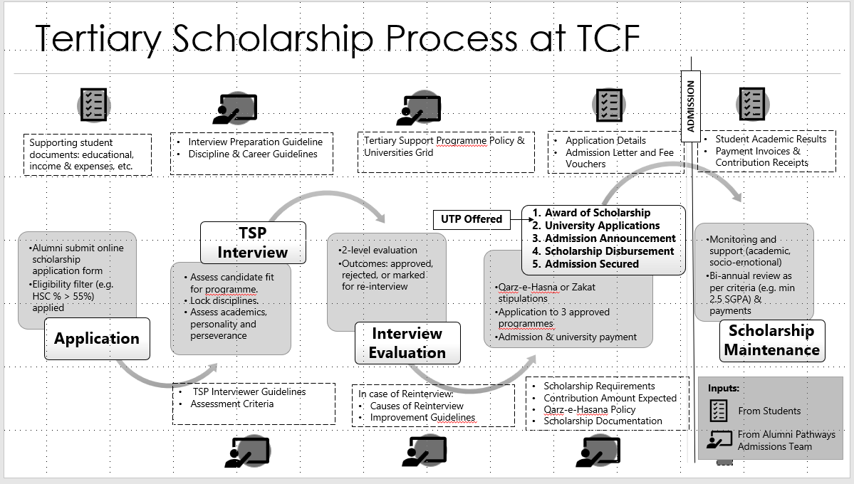

2.2 TERTIARY SCHOLARSHIP APPLICATION:
After nationwide outreach, an online application form is launched for TCF alumni intending to pursue tertiary education. Eligible candidates submit applications within the designated timeline.

2.2.1 Programme Selection
✔ Students may apply to any programme within the approved disciplines.
✔ They must discuss options with the Alumni Pathways team to receive guidance on best-fit programmes and universities.

  - SCHOLARSHIP INTERVIEW
All applicants must pass an internal TCF interview (in-person/online) to receive a scholarship. Intermediate results available at the time of the interview will be considered.

For the North and North West regions, since first-year practical results are released along with the second-year results, the marks calculated at the time of the interview will exclude practical scores if second-year results are not yet announced.

    - Evaluation Criteria
The interview evaluates students on the following criteria:
✔ Academic history
✔ Knowledge of chosen discipline
✔ Strengths, weaknesses, career goals
✔ Behavioural readiness

2.3.2 Interview Preparation
Students are strongly encouraged to:
- Review the Discipline Guide and other preparatory materials shared by the TCF Alumni Pathways team.

- Attend an initial counseling session with the team to improve their readiness and align their choices with available opportunities.

2.3.3 Interview Schedule
TCF conducts scholarship interviews twice a year.
- Cycle 1 begins approximately one month after the announcement of intermediate exam results, with decisions finalized within three months.
- Cycle 2 commences in June each year.

    - Scholarship Approval
✔ Approval is discipline-based, not programme-specific
✔ Students can be approved for up to 2 disciplines
✔ Students must prepare for minimum 2 programmes per discipline
✔ Private College or Self-Funded MBBS/BDS approval require special GM approval

If a student is admitted into a non-approved discipline, students must undergo re-interview for re-approval.

2.3.5 UNIVERSITY TEST PREPARATION (UTP)
The University Test Preparation (UTP) programme is designed to support candidates aiming for admission to Tier 1 universities, with the goal of increasing the number of quality placements. UTP may also be extended to candidates applying to Tier 2, 3, 4, or lower-ranked universities, subject to approval by the General Manager, Alumni Pathways.

Eligibility Criteria for UTP:
✔ Must be currently enrolled in Grade XII or have completed Intermediate studies
✔ For pursuing BCAT / ECAT: 55% or above in Grade XI or cumulative Intermediate percentage
✔ For pursuing MDCAT: 75% or above in Grade XI or cumulative Intermediate percentage
✔ Student must be approved for tertiary scholarship by the Alumni Pathways team

Cost of UTP is fully covered by TCF. MDCAT and SAT test exam cost is borne by TCF for selected high performing students with the approval of GM, Alumni Pathways.

2.4 SCHOLARSHIP CONTINUATION & WITHDRAWAL

2.4.1 Academic Requirements
✔ Maintain minimum Semester Grade Point Average (SGPA) of 2.5.
✔ Students must self-fund failed/dropped courses. TCF may assist, with repayment in installments. If a student is unable to pay the required amount, prior approval must be obtained from the General Manager, Alumni Pathways. The approved amount will then be added to the student's total scholarship expense.

2.4.2 Conduct & Compliance
Students must comply with university regulations and TCF values.

2.4.3 Probation Policy
If a student secures a Semester Grade Point Average (SGPA) below 2.5, they will be placed on probation for the following semester.

Types of Probation:
With Intensive Support Intervention | With Minimal Support Intervention
✔Triggered by poor academic performance where the student is unable to address or overcome the challenges independently.  ✔Includes academic coaching, tutoring (max 2 months), financial aid.  ✔Student must sign an undertaking if receiving tutoring funds. | ✔For students facing temporary personal challenges expected to self-resolve.  ✔Basic-level counselling to support self-assessment and improve academic performance is provided by the Alumni Pathways team.

2.4.4 Scholarship Cancellation
Triggers:
- Continued low academic performance
- Behavioural misconduct
- Document forgery
- Incompatibility with programme (within first semester)

In such cases, students may be:
- Redirected to alternate programmes or pathways.
- Required to re-apply through the full application cycle.

Scholarship cancellations will be thoroughly reviewed by the team, Senior Manager, and General Manager, Alumni Pathways before finalization.

2.4.5 Key Cancellation Reasons
There are majorly three reasons for scholarship cancellations which are discussed below:

A. Academic
- Poor GPA or repeated course failures
Student is allowed to reapply for scholarship after academic improvement

B. Behavioural
- Policy violations or serious misconduct
- Tampering with documents
If a student's scholarship is cancelled due to behavioral misconduct, they will no longer be eligible for any future scholarships.

C. Personal Circumstances
- Family responsibilities, financial hardship
- Health issues or caregiving duties
Student may shift to alternate programmes or reapply later.

2.4.6 Re-Admission
Students may be redirected to an alternative university programme. In such re-admission cases, the entire application process—including a fresh student assessment—must be completed again.

2.5 MONITORING & COMPLIANCE

2.5.1 Performance Tracking
✔ Semester wise academic tracking
✔ Compliance checks and documentation reviews

2.5.2 Scholarship Termination Process
✔ Review by Alumni Pathways team
✔ Approval by GM, Alumni Pathways
✔ Final decision communicated in writing to the student

UNIVERSITY SELECTION & APPLICATION

3.1 UNIVERSITY SELECTION PROCESS FOR APPLICATION
• All university applications must be routed through TCF.
• In cases where a student applies independently, the application may still be considered, subject to an interview and approval by the General Manager (GM), Alumni Pathways.
• TCF funds application fees for up to three universities per student. Students must select these universities in consultation with the Alumni Pathways team. A fourth application is discouraged and will only be allowed in exceptional cases with the GM’s approval.
• For universities with multiple campuses, initiating admission at a specific campus also requires GM-level approval.

University Categories for Financial Support
Category | Description | Reference
Within PKR 800,000 per annum | Standard support | Appendix E
Above PKR 800,000 per annum, underwritten by TCF | Extended support | Appendix F
Above PKR 800,000 per annum, not underwritten by TCF (Tier 1 & 2) | Conditional support | Appendix G
Above PKR 800,000 per annum, not underwritten by TCF (Tier 3 & 4) | Minimal support | Appendix H

3.2 University Application Attempt Limit
• TCF will bear the cost for up to three application attempts. Typically, one application allows the selection of three programmes within a university.
• A fourth application attempt requires approval from GM, Alumni Pathways.
• Support for specific programmes may depend on donor approval.
• Students selected on merit for highly competitive universities (e.g., AKU, LUMS) are prioritized.

3.3 Academic Discipline, Group, and Programme Classification
TCF supports a wide range of undergraduate programmes across Pakistan. Programmes are categorized into:
- Disciplines (e.g., Health Sciences, Management Sciences, Computer Studies)
- Groups within disciplines (e.g., Computer Science, Information Technology)
- Specific Programmes (e.g., BS Cyber Security, BS Artificial Intelligence)

Example:
- Discipline: Computer Studies | 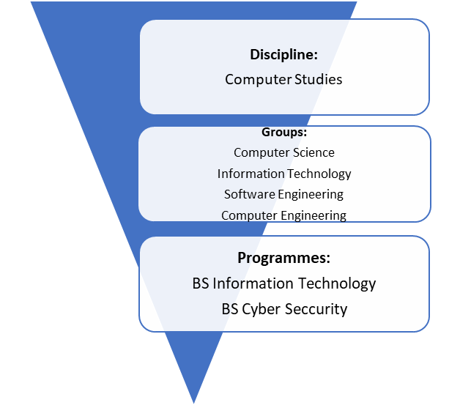
- Groups:
  - Computer Science
  - Information Technology
  - Software Engineering
  - Computer Engineering

- Programmes: BS Information Technology, BS Cyber Security

3.4 TIER CATEGORIZATION
3.4.1 Tiers
Universities are ranked from Tier 1 to Tier 4 based on the employability of their graduates. The ranking considers factors such as job placement rates, starting salaries, industry reputation, alumni networks, geographic relevance, and HEC accreditation. Tier 1 universities perform strongly across these areas, while lower tiers show a gradual decline in graduate outcomes and overall institutional quality.

Asterisks (*) – Some universities listed under Tier 4 are marked with an asterisk (*). This indicates that these universities are the only local options available in a particular city or region and will be supported due to the limited availability of alternatives.
3.4.2 Premier League of Universities
The Premier League of universities is positioned as a supra-tier within the Tier 1 classification on the basis of prestige and cost.
These are elite institutions categorized above Tier 1, supported despite exceeding the PKR 800,000 annual cap, due to exceptional quality and prestige.
Key Traits:
- Superior employment outcomes and academic excellence
- National and international brand value
- Influential alumni networks
- All academic programmes offered by a premier league university fall in Tier 1 as per TCF Tertiary Support Programme policy
- High tuition fees (above PKR 800,000 per annum)
List of Premium Universities and their Programmes
- Aga Khan University (AKU) – Karachi
- Ghulam Ishaq Khan Institute of Engineering Sciences and Technology (GIKI) – Topi, Swabi
- Habib University (HU) - Karachi
- Institute of Business Administration (IBA) – Karachi
- Lahore University of Management Sciences (LUMS) – Lahore

c. TSP-Approved Disciplines and Scholarships Offered by Premier Universities
University | Disciplines | Financial Assistance | Merit Scholarships
AKU | Health & Social Sciences | Need-based | Merit-based
GIKI | Engineering, Computer Science, Management | Need-based | 20 merit-based
Habib University | Computer Sciences, Engineering, Arts & Humanities | Need-based | Habib Merit, HUTOPS
IBA | Computer Sciences, Management, Social Sciences, Mathematics | Need-based | IBA-NTHP
LUMS | Management, Social Sciences, Computer Sciences | Need-based | NOP 100 merit scholarships

Programme details of above universities can be viewed in Appendix B.

3.4.3 Scholarship Preferences by Tier (All Programmes)

The table presents the likelihood of scholarship availability across various categories, tiers, and university types, along with a priority list indicating TCF’s potential scholarship preferences based on the offerings of higher education institutions.
Category | Premium | Tier 1 | Tier 2 | Tier 3 | Tier 4
NOP, NTHP, TOPS, Ehsaas, Partnership | High | High | High | High | Not Applicable
Public Universities  (< PKR 800K) | High | High | High | Moderate | Low
Private Universities  (< PKR 800K) | High | High | Moderate–High | Low | Low
Public Universities  (> PKR 800K) | High* | Conditional partial support | Low | Low | Lower
Private Universities  (> PKR 800K) | High* | Conditional partial support | Low | Lower | Lower
*Subject to funding availability and student performance.

3.4.4 Scholarship Preferences by Tier (MBBS, BDS and Nursing)
Category | Tier 1 Premium | Tier 1 | Tier 2 | Tier 3 | Tier 4
Public  (Merit-based) | High | High | High | Moderate | Low
Private  (Merit-based) | High* | Low | Low | Low | Low
Public  (Self-finance) | High | High | Not Applicable | Not Applicable | Not Applicable
Private  (Self-finance) | Not Applicable | Not Applicable | Not Applicable | Not Applicable | Not Applicable
*Subject to approval from GM, Alumni Pathways
- Tier 1 self-finance support is contingent on available funds

- Tier 2 self-finance admissions only with pre-arranged donor funding

3.4.5 Private vs. Public Universities within the Same Tier
Private universities are generally preferred due to:
- Stronger academic rigour and market-aligned curricula
- Better employment outcomes and industry linkages
- Comprehensive student development opportunities
- Earlier admission timelines compared to public universities
However, TCF discourages admissions to overly expensive private institutions (excluding Premier League) when more affordable, equally effective options exist. Final decisions consider employability, industry perception, alumni experience, and student preference.

Notes:
- High-Cost Non-Premium Programs:
Any university program—excluding MBBS—that exceeds an annual cost of PKR 800,000 and is not part of the premium university list will require special approval from senior management.

- Treatment of Multi-Campus Universities:
Universities operating under a single governing board and standardized curriculum are considered as one entity, regardless of campus location. Examples include:
  - Ziauddin University
  - FAST University
  - COMSATS University
  - Shaheed Zulfikar Ali Bhutto Institute of Science & Technology (SZABIST)

- Premium University Programs – High Rigor Designation:
All disciplines and programs offered by premium universities are considered high rigor.
  - There is no cap on funding; donor pitching will be pursued to raise the required funds.
  - There is no limit to the number of students who can receive TCF scholarships in these universities.
  - In cases where a student was previously disapproved, the scholarship interview will be fast-tracked for timely resolution.

- Financial Ceilings for Other Universities:
Some universities listed in the selection grid (e.g., Hamdard University) must adhere to the financial ceilings outlined in the tier selection framework. Any program exceeding PKR 800,000 annually will not be eligible unless special approval is obtained

For Reference:

UNIVERSITY INCLUSION CRITERIA

All 176 universities included are either:
✔Higher Education Commission (HEC) recognized
✔Affiliated with HEC-recognized universities
Breakdown:
✔126 HEC recognized universities
✔46 affiliated universities
(See Appendix D for a) Complete University Approval & Ranking Process b) Complete University Classification)

HEC recognition is a mandatory requirement for any institute to award degrees in its own name. It serves as formal confirmation that a university or its academic programmes meet the quality standards established by the Higher Education Commission (HEC).

Affiliated institutions are formally linked to HEC-recognized universities, allowing them to offer academic programmes that follow the curriculum approved by the parent university. Students enrolled in these institutions receive their degrees from the HEC-recognized university with which the institution is affiliated.

- Inclusion of Affiliated Colleges:
Affiliated colleges of HEC-recognized universities (with a minimum of six years of affiliation) have been considered in cities outside Karachi, Lahore, and Islamabad.
  - However, due to the limited availability of specific programs—particularly in Law and Criminal Studies under Social Sciences and Arts—some affiliated colleges within the KLI region were also included.
  - Additional exceptions apply to select programs in Health Sciences and Social Sciences and Arts, as outlined in the relevant sections above.

POLICY ON CHANGES IN DISCIPLINE, UNIVERSITY, AND/OR LOCATION

TCF encourages thoughtful decision-making during the university admission process. However, if a change in discipline, university, or location is necessary, the following guidelines and approval mechanisms apply.

  - Change in Discipline or University - Before Admission

4.1.1 Admission Offered in a Non-Approved Discipline
- If a student gains admission in a discipline that was not approved during the scholarship interview, a re-interview will be required.
- This option is given only if the new admission is in a Tier 1 or Tier 2 university program. Tier 3 and Tier 4 admissions will only be catered to possible.

4.1.2 Request to Change Approved Discipline Before Application/Admission
- If a student wishes to change their approved discipline, he/she is required to consult the TCF Alumni Pathways Team for clarification and guidance before initiating any changes.
- No changes in discipline or admission into an unapproved program will be accepted without re-interview and formal approval.
- The requisite re-interview can only be scheduled in the next interview cycle.

4.2 Change in Discipline or University - After Admission

4.2.1 Steps and Conditions for Changing University
- Initial Consultation
  - Students must notify the TCF Alumni Pathways Team before making any decisions regarding a change in university or program.
  - The team will review the case and provide individualized guidance.
- Approval Process

Approval is at the sole discretion of the TCF Alumni Pathways Team.

Only cases demonstrating genuine, unavoidable necessity will be considered.

4.2.2 Repayment of Funds
- If a university change is approved after disbursement, the student must repay the full amount provided to the first university.
- Ideally, repayment should be completed before enrolling in the new institution.
- If immediate repayment is not feasible, students may request an installment plan, subject to approval by TCF.

4.2.3 Scenarios with Higher Likelihood of Approval

a. Upgrade to a Higher-Tier University

Example: A student initially admitted to a Tier 3 university later receives admission to a Tier 1 institution.

4.2.4 Scenarios with Lower Likelihood of Approval

a. Changes Based on Personal Preference or Cultural Discomfort

Example: A request to change university due to a preference for a different environment or personal adjustment issues.

b. Switching Between Public and Private Institutions

Example: Moving from a public to a private university (or vice versa) for non-academic reasons.

TCF prioritizes resource optimization and cost-effectiveness, making such cases difficult to approve.

4.3 Relocation for Higher Education (Changing Hometown)
- Students are generally expected to pursue higher education within their hometown.
- Relocation will only be considered when:
- No Tier 1 or Tier 2 options are available locally in the chosen discipline.
- The student has secured admission in a Tier 1 or Tier 2 institution outside the hometown.
- Additional Guidelines:
- Relocation to Karachi, Lahore, or Islamabad (KLI) for Tier 3 or Tier 4 programs is strongly discouraged.
- Such relocation may only be considered within the same province/region if KLI is not involved.

Important Notes

All proposed changes must be discussed with the TCF Alumni Pathways Team beforehand. This ensures appropriate guidance and protects both the student’s academic trajectory and TCF’s resource commitments. Students are expected to act with maturity, responsibility, and transparency when seeking such changes.

4.1 Change in Discipline or University Before Admission

4.1.1 Admission in Non-Approved Disciplines
If a student receives admission in a discipline not approved during the scholarship interview, a re-interview will be conducted only if:
- The admission is secured in a Tier 1 or Tier 2 university program.

4.1.2 Request for Change in Approved Discipline
- If a student wishes to change their approved discipline after the scholarship interview, the request will only be considered during the next scheduled interview cycle.
- Any change in discipline, or admission into a non-approved program, requires prior approval through the re-interview process.
- For guidance or clarification, students must contact the TCF Alumni Pathways team before proceeding.

4.2 Change in Discipline or University After Admission
TCF expects scholarship recipients to carefully select their university and discipline prior to final admission. Any change after admission is strongly discouraged and will only be considered in exceptional circumstances based on merit.

4.2.1 Steps and Conditions for Changing University
a. Initial Discussion with TCF
- Students must inform the TCF Alumni Pathways team prior to making any decisions regarding a university change.
- The team will assess the situation and provide appropriate guidance.
b. Approval Process
- The decision to approve a change of university is entirely at the discretion of the TCF Alumni Pathways team.
- Approval will be granted only in cases of genuine and unavoidable necessity.

4.2.2 Repayment of Funds
- If a university change is approved, the student must repay the full amount disbursed to the first university.
- Ideally, this repayment should be completed prior to enrolling in the second university.
- In case the student is unable to repay the entire amount upfront, they may request a payment plan in installments, subject to TCF’s approval.

4.2.3 Cases with Higher Probability of Approval
a. Upgrade to a Higher-Tier University
- Example: A student originally admitted to a lower-tier institution subsequently gains admission to a Tier 1 university.

4.2.4 Cases with Lower Probability of Approval
a. Changes Due to Personal Preferences or Cultural Adjustment
- Example: Requests based on discomfort with university culture, or personal choice, are unlikely to be approved.
- Students are expected to make informed and thoughtful decisions before accepting an offer.
b. Switching Between Public and Private Universities
- Example: Requesting a move from a public to a private university (or vice versa) for personal reasons.
- Such cases carry a lower likelihood of approval, given TCF's focus on responsible resource utilization.

4.3 Relocation for Higher Education (Changing Hometown)
- Students are expected to prioritize universities located within their hometown.
- Relocation to another city may be considered only when:
  - The home city lacks Tier 1 or Tier 2 university options in the relevant discipline.
  - The student has secured admission in a reputed Tier 1 or Tier 2 university outside their hometown.
- Relocation for Tier 3 or Tier 4 programs is only permissible in non-Karachi, Lahore, Islamabad (KLI) areas within the same region.
  - Relocation to KLI cities for Tier 3 or Tier 4 programs is strongly discouraged and will generally not be supported.

Notes:
- Students must consult the TCF Alumni Pathways team before initiating any change to their university or discipline.

- This ensures appropriate guidance and supports optimal outcomes for the student and the organization.

- Students are advised to exercise careful judgment and responsibility in using this opportunity.

5. Hostel & Mess Support

This section outlines the policy and procedure for financial support toward hostel accommodation and mess (meal) expenses for eligible TCF alumni enrolled under the Tertiary Scholarship Programme (TSP).

5.1 ELIGIBILITY CRITERIA
- Hostel and mess expense support is available to TCF alumni who have successfully cleared the TSP interview process.
- Support is granted based on demonstrated financial need, as determined through a detailed need assessment by the Alumni Pathways Team.

5.2 APPLICATION AND APPROVAL PROCESS

5.2.1 Application submission
- Eligible alumni must submit their scholarship application via the designated online portal.
- The application must be fully completed and accompanied by the following mandatory supporting documents:
- Hostel and/or mess fee voucher
- Affidavit, in case the official voucher is not available, attesting to the legitimacy of the expense
- Undertaking, if the student is opting for a private hostel, confirming the nature and cost of accommodation

5.2.2 Review and Approval
- The Alumni Pathways Team will review the submitted application and supporting documentation to assess need and determine the appropriate level of support
- The final decision, including the amount approved, will be communicated to the student via email / shared file.
- If the application is incomplete, the student will be informed and given the opportunity to provide the missing information
- All approvals are subject to the availability of funds and authorization from the General Manager, Alumni Pathways.

TRANSPORT SUPPORT

This section outlines the provision of transport-related financial support for eligible TCF alumni under the Tertiary Scholarship Programme (TSP). TCF provides inter-city transport support only. Intra-city (within-city) transport expenses are not covered under any circumstances.

6.1 ELIGIBILITY CRITERIA
- Transport support is available to TCF alumni who have cleared the TSP interview and demonstrated financial need.
- Support is assessed and disbursed on a semester-wise basis.
- Eligibility is determined by the Funds Team, based on a combination of the following factors:
  - Distance between the student’s residence and university (intercity travel)
  - Financial background and need assessment
  - Academic performance and progress
  - Completeness and accuracy of application materials
- Students receiving hostel support are not eligible for transport support. However, exceptional cases (e.g., short-term temporary arrangements or outlier circumstances) may be considered on a case-by-case basis at the discretion of the Scholarships and Alumni Affairs Team.
- Continuation of transport support is subject to a semesterly review and compliance with TSP’s scholarship maintenance requirements.

6.2 APPLICATION AND APPROVAL PROCEDURE

6.2.1 Application Submission
- Students must apply for transport support through the official online scholarship portal.
- Applications must be complete and include the following mandatory supporting documents:
  - A valid transportation bill or voucher (e.g., bus/train ticket or transport pass)
  - An affidavit, only in cases where a valid voucher is unavailable, affirming the expense and its academic relevance

6.2.2 Review and Decision Process
- The Alumni Pathways Team will evaluate submitted applications and supporting documents.
- Students will receive a notification via email / portal / shared file regarding the final decision.
- If the application is incomplete, the student will be contacted to provide the missing information.
- Final approval is subject to the availability of funds and authorization by the General Manager, Alumni Pathways.

MISCELLANEOUS SUPPORT

This section outlines the policy for providing financial assistance to TCF alumni under the Tertiary Scholarship Programme (TSP) for non-standard academic expenses. This support specifically excludes costs related to semester fees, hostel accommodation, mess charges, and transport.

7.1 SCENARIOS FOR SUPPORT
- Unpaid Cases – Where support is requested prior to the expense (e.g., advance for purchasing material, or direct university/vendor payment).
- Reimbursement Cases – Where the student has already incurred and paid the expense due to urgency and seeks post-payment reimbursement.

7.2 ELIGIBILITY CRITERIA
- The applicant must be a TCF alumnus currently supported under the TSP.
- The request must relate to academic, project, thesis, or research-related expenses that are not covered under regular scholarship disbursements.
- Requests are evaluated on a semester-wise basis.

7.3 APPLICATION AND APPROVAL PROCEDURE

7.3.1 Application Submission

The student must submit a formal request to the Alumni Affairs Team along with the following mandatory supporting information / documents:
- Student identification and contact details
- Clear explanation and justification of the expense
- Unpaid bill/voucher – for direct payments
- Paid bill/voucher – for reimbursements, along with bank account details of the student or a direct family member
  - Affidavit – in case of missing invoice/bill, attesting to the legitimacy of the expense
  - Most recent academic transcript or result card

7.3.2 Review and Decision
- The Alumni Pathways Team will evaluate all applications for completeness, relevance, and justification of cost.
- The student will be notified of the decision via email.
- Incomplete applications will be returned with a request for the missing information.
- Final approval is contingent upon:
- Verification of all documentation
- Availability of funds
- Approval by the General Manager, Alumni Pathways

7.4 FUND CAP POLICY

Support is subject to a maximum cap, determined after evaluation of the expense by the Alumni Pathways Team based on:
- Reasonableness and academic relevance of the request
- Market rates for the material/service

- Historical benchmarks for similar requests
- Any amount exceeding the approved cap must be borne by the student.

7.5 STUDENT RESPONSIBILITIES
- Students must ensure that all submitted information and documents are accurate and truthful.
- Students are expected to retain and submit receipts or additional proof of purchase upon request, especially in reimbursement cases.
- Students are expected to exercise financial prudence, avoiding unnecessary or luxury expenses under this support category.
- All project-related purchases must be directly tied to academic outcomes and, where possible, pre-approved by relevant university departments.

TERMS OF PAYMENT

  - ZAKAT

Students receiving financial assistance under the Zakat Fund must meet the criteria of Zakat eligibility as prescribed by Islamic principles. This includes:
- Demonstrating genuine financial need
- Submitting a duly signed declaration or affidavit of Zakat eligibility, as required by TCF

All Zakat disbursements are subject to verification and compliance with applicable religious and institutional guidelines.

  - QARZ-E-HASANA

8.1 Definition
Qarz-e-Hasana is defined as interest-free financial assistance extended to students based on goodwill and moral responsibility. It is not legally enforceable, carries no fixed repayment schedule, and is provided to enable students to pursue their academic goals in good faith.

8.2 Repayment Policy
- Repayment of Qarz-e-Hasana is entirely voluntary.
- TCF does not initiate any recovery process or follow-up communication regarding repayment.
- Any unused or unreimbursed amount associated with a student’s academic support may be recorded as part of their Qarz-e-Hasana balance, without imposing any obligation or pressure to repay

8.3 STUDENT CONTRIBUTION POLICY

8.3 Definition of Contribution
Student contribution refers to the portion of the university fee paid directly by the student, with the remaining amount covered by TCF. This co-payment model is designed to:
- Ensure students are active stakeholders in their educational journey
- Instill a sense of ownership, responsibility, and commitment
8.3. Contribution Calculation Methodology
- A standard 3% of the household’s total monthly income is allocated as the family's contribution toward higher education.
- In cases where two students from the same household are enrolled in university simultaneously, the 3% allocation is equally divided between them.
- The student's semester-based contribution is calculated is calculated at the time of scholarship award using the following formula:
{Individual Share of 3% Income} × {Number of Months in the Semester} = Total Contribution

IMPORTANT NOTES

9.1 PRICE CAPS
In the case of exceptionally high-cost university programmes within a given discipline and tier, the TCF Alumni Pathways Team exercises discretion and prioritizes institutions that offer optimal value for money. While there is no cap on the number of students who may secure admission to Tier 1 universities—nor a restriction based solely on university cost—students are strongly encouraged to apply for external scholarships when opting for high-fee institutions.
Admission to private medical universities remains subject to the availability of funds.
For further details, refer to Appendix G.

9.2 ENRICHMENT COURSES DURING SCHOLARSHIP
To support holistic development and employability, TCF may offer enrichment courses to tertiary scholarship recipients. These courses aim to equip students with practical and professional skills ahead of graduation and are provided subject to team approval.

9.3 POLICY REVIEW AND UPDATE STATEMENT
This policy will remain effective for a minimum period of three years from the date of issuance. During this time, the core principles and structural guidelines of the policy shall remain unchanged.
However, specific operational components—including price caps, support ceilings, and the inclusion of newly introduced programmes or institutions—will be reviewed on an annual basis. Revisions may be made in response to updated data, budgetary constraints, or evolving student needs.
All modifications will be formally documented through addendums or revision notes attached to this policy.

Disclaimer:
All TSP Policy 2025 guidelines serve as overarching principles to guide decision-making across all related areas. Any decisions falling outside the scope of these guidelines must be reviewed and approved by senior management.

GLOSSARY
Affidavit | A written statement confirmed by oath or affirmation, used when official documents (e.g., hostel vouchers) are unavailable.
CGPA | Cumulative Grade Point Average – A cumulative measure of academic performance over the entire degree program.
EasyPaisa | A digital wallet/mobile money service used for disbursing payments to students without bank accounts.
GPA | Grade Point Average – A measure of academic performance over a semester or academic term.
HSSU | Higher Secondary School Units
IBFT | Interbank Funds Transfer – A method of transferring scholarship funds directly to students' bank accounts.
KLI | Karachi, Lahore, Islamabad – Major urban centers in Pakistan used as reference points for university location policies.
NOP / NTHP / TOPS | National Outreach Programmes such as LUMS NOP, IBA NTHP, and other top university outreach scholarships.
Premier League Universities | Select top-tier universities supported by TCF regardless of cost, based on academic excellence, employment outcomes, and prestige.
Self-Finance Admission | Admission based on payment of full fee rather than merit-based subsidized seats, especially in medical universities.
SGPA | Semester Grade Point Average – The GPA for a specific academic semester.
TCF | The Citizens Foundation – a non-profit organization supporting the education of underprivileged students in Pakistan.
Tier 1–4 Universities | A categorization of universities based on employability outcomes, industry reputation, and academic quality. Tier 1 is the highest.
TSP | Tertiary Support Programme – TCF’s scholarship and support initiative for alumni pursuing higher education.
Undertaking | A formal pledge by the student and parent/guardian to abide by specific terms, such as for private hostel arrangements.
UTP | University Test Preparation - classes that offer structured learning for various standardized university exams like MCAT, BCAT, ECAT, NTS, etc
Voucher | A documented bill or invoice required for reimbursement or advance payment requests.

Appendix

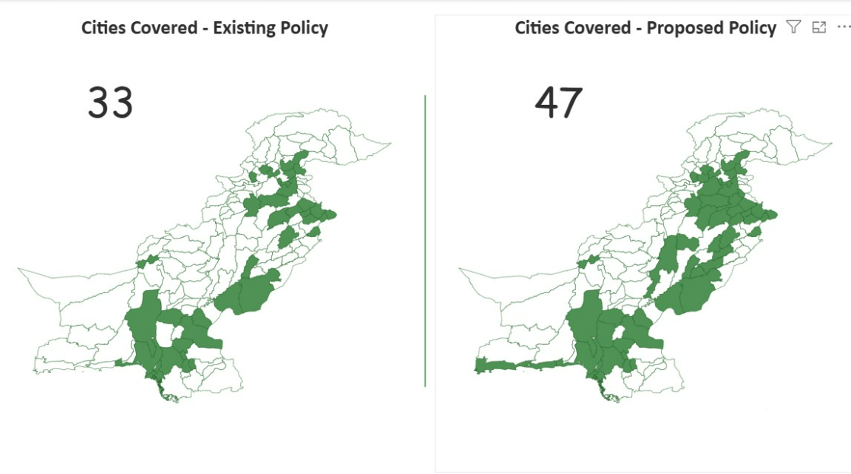
43
Cities Covered – Policy 2025
Cities Covered – Previous Policy
33

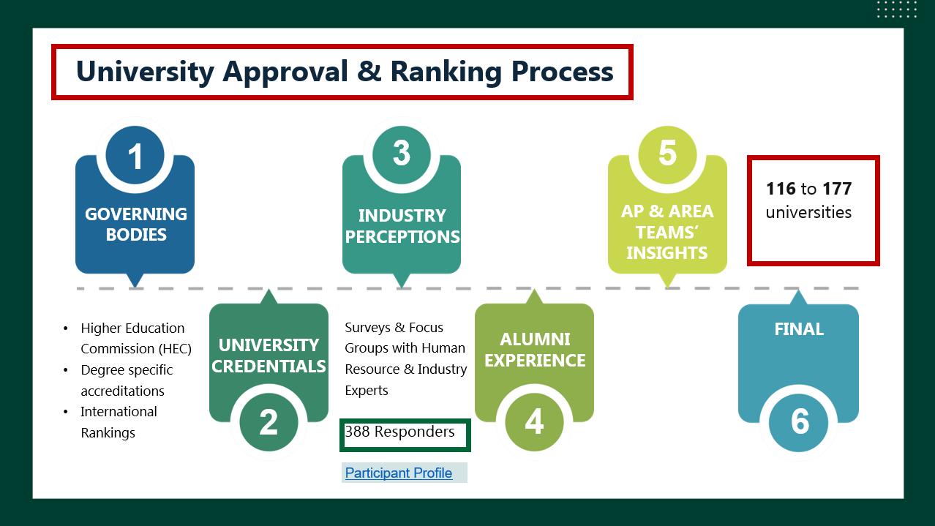

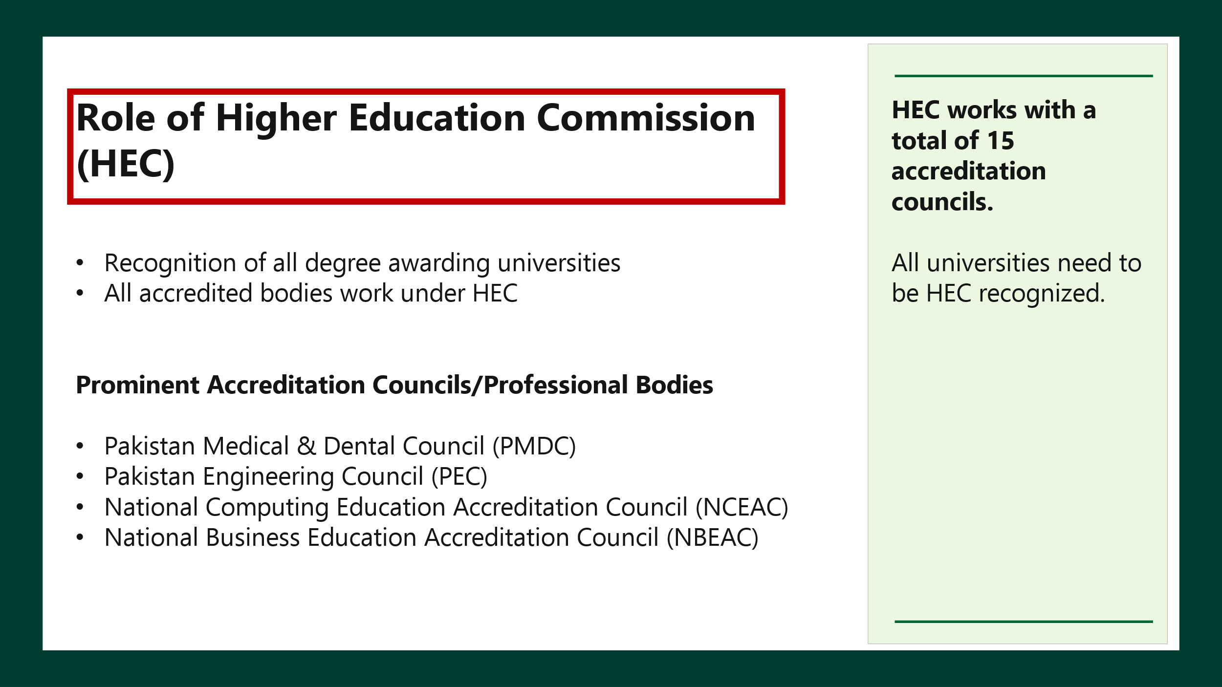
DISCIPLINES
COMPUTER STUDIES | ENGINEERING | HEALTH SCIENCES | MANAGEMENT SCIENCES | NATURAL SCIENCES | SOCIAL SCIENCES & ARTS | AGRICULTURAL SCIENCES
Groups & Programmes | Groups & Programmes | Groups & Programmes | Groups & Programmes | Groups & Programmes | Groups & Programmes | Groups & Programmes
Computer Science  (Artificial Intelligence, Business Analytics & Programming, Business Data Analytics, Computing & Data Sciences, Data Analytics, Data Science)  Computer Engineering  Information Technology  (Cyber Security, Information Management, Information Security)  Software Engineering | Aerospace & Aeronautical Engineering  (Aircraft Maintenance & Technology, Aviation Management, Avionics Engineering)  Biotechnology & Biomedical Engineering  (Medical Engineering)  Chemical & Petrochemical Engineering  (Petrochemical Engineering, Petroleum & Gas Engineering, Petroleum Engineering)  Civil & Environmental Engineering  (Energy Systems Engineering, Geological Engineering, Water Resource Management)  Electrical & Electronics Engineering  (Telecommunication, Telecommunication Engineering)  Industrial and Manufacturing Engineering  (Industrial Engineering and Management)  Materials, Mining & Textile Engineering  (Garment Engineering, Materials Engineering, Metallurgy and Materials, Engineering, Mining Engineering, Polymer Engineering, Textile Engineering)  Mechanical Engineering  (Mechatronics and Control Engineering, Mechatronics Engineering) | Medicine  MBBS  (Bachelor of Medicine, Bachelor of Surgery)  Dentistry  BDS  (Bachelor of Dental Surgery)  Nursing  BS Nursing  (Bachelor of Science in Nursing)  Clinical & Medical  (DVM (Doctor of Veterinary Medicine), Anesthesia, Cardiology, Dental Hygiene, Orthotics & Prosthetics, Speech and Language Pathology, Veterinary Medicine)  Allied Health  (DPT (Doctor of Physical Therapy), Emergency and Intensive Care Sciences, Nursing, Occupational Therapy, Operation Theater Sciences, Operation Theater Technology, Physical Therapy, Physiotherapy, Respiratory Therapy & Critical Care Sciences, Dialysis and Critical Care Sciences)  Pharmaceutical & Nutritional Sciences  (Eastern Medicine, Food Engineering, Food Nutrition & Dietics, Food Science & Human Nutrition, Food Science & Nutrition, Food Sciences, Food Sciences & Technology, Human Nutrition & Dietetics, Nutrition, Nutritional Sciences, Pharm-D)  Vision Care, Diagnostic & Technical  (Clinical Laboratory Sciences, Medical Lab Technology, Medical Laboratory Technology, Medical Technician, Medical Technology, Medical Ultrasound Technology, Optometry, Radiological Imaging, Radiology, Radiology Technology, Nuclear Medicine and Radiotherapy) | Business Administration & Management  (Business Information Systems, Commerce, Digital Marketing, Management and Technology, Management Sciences, Project Management, Supply Chain Management, Healthcare Management)  Finance & Economics  (Accounting, Accounting & Finance, Actuarial Science and Risk Management, Anti-Money Laundering, Banking & Finance, Economics & Mathematics, Economics with Data Science, Islamic Banking and Finance, Islamic Economy and Banking)  Tourism & Hospitality  Chartered Accountancy (CA) | Biological Sciences  (Bio Informatics, Biological Sciences, Biology, Botany, Genetics, Microbiology, Molecular Biology, Zoology)  Chemistry, Physics & Marine Science  (Biochemistry, Forensic Chemistry)  Statistics & Mathematics  (Applied Mathematics) | Architecture  (Architecture, Interior Design)  Art & Design  (Ceramic & Glass Design, Computer Arts  Design, Fine Arts, Furniture Design & Manufacture, Interior Design, Jewelry Design & Gemological Sciences, Leather Accessories & Footwear, Product Design)  Education  (Education & Research, Special Education)  Fashion & Textile  (Fashion & Accessories Design, Fashion Design, Fashion Marketing & Merchandising, Textile Management and Marketing)  Health & Physical Education  Islamic & Comparative Religions Studies  (Islamic Studies, Comparative Religions, Comparative Studies, Comparative Literary & Cultural Studies  Language & Literature  (Applied Linguistics, English, English Literature, Language, Linguistics, Literature, Pashto, Sindhi, Urdu, Urdu Literature, Arabic)  Law & Criminal Studies  (Criminal Studies, Criminology)  Media Sciences & Communication  (Communication and Design, Film & Television, Graphic Design, Journalism & Mass Communication, Music, Visual Communication Design)  Political & Social Sciences  (Anthropology, Behavioral Science, Cultural Studies, Defense & Strategic Studies, Disaster Management, Environmental Sciences, Environmental Management and Policy, Gender Studies, Geography, Geology, History, International Relations, International Studies, Library & Information Science, Pakistan Studies, Philosophy, Politics & Economics, Psychology, Public Administration, Public Policy, Public Health, Social Development & Policy, Social Work, Sociology) | Agricultural Sciences  (Agriculture Engineering, Animal Sciences, Dairy Technology, Entomology, Fisheries & Aquaculture, Fishery & Aqua Culture, Forestry, Poultry Science, Wildlife and Fisheries)

APPENDIX A: UNDERSTANDING THE UNIVERSITY GUIDANCE FRAMEWORK
This guide provides instructions on how to interpret and utilize the Tertiary Support Policy Grid to identify which undergraduate university programmes are eligible for support under TSP Policy.

1. Structure of the University List
The grid is organized by discipline, and each discipline is further divided into academic groups. Each academic group contains related undergraduate programmes.

Example:
- Discipline: Management Sciences
- Group: Business Administration & Management
This group includes programmes such as BBA, Business Information Systems, Digital Marketing etc

2. University Sector
Each university is listed under one of the following sectors:
- Public
- Private

3. Tiers (Tier 1 to Tier 4 & Below)
Universities are classified into tiers based on quality, reputation, and strategic relevance:

Universities are categorized into Tier 1 to Tier 4 based on the employability outcomes of their graduates, with Tier 1 institutions consistently producing the most employable graduates—measured through job placement rates, starting salaries, and industry reputation—while each subsequent tier reflects a gradual reduction in these outcomes.

4. Asterisks (*) – Limited options within an area or a city
Some universities listed under Tier 4 are marked with an asterisk (*). This indicates that these universities are the only local options available in a particular city or region and will be supported due to the limited availability of alternatives.

5. City Information

• Each university is listed with its main city/campus.

• If a university has multiple campuses, it will have a small number next to its name (e.g., Air University – AU¹).

• That number can be matched with the list later in the document (included after the university guide) to identify all campus locations.

This helps in finding the closest university to alumni’s hometowns.

6. Eligibility for Support
To qualify for support:
- The applicant must gain admission to a university listed in the grid, within the relevant discipline and programme group.
- The chosen university must fall within Tier 1, Tier 2, Tier 3, or Tier 4. Moreover, universities marked with an asterisk (*) will also be supported.
7. How to Use This List
- Identify the relevant discipline (e.g., Management Sciences)
- Locate the correct academic group (e.g., Business Administration & Management)
- Search for the university where admission has been secured or is desired
- Note the tier, sector, and location of the university
- Use the criteria above to determine whether the programme qualifies for support
  - The university is in Tier 1–4
  - Or if in Tier 4, it has an asterisk (*) and meets the location-based criteria for support i.e., there are no other universities or institutions in that area that meet the TSP criteria.
- Please refer to sections 3.4.3 and 3.4.4 to see the probability of being awarded scholarship.

Example Walkthrough
A student secures admission to Shaheed Zulfikar Ali Bhutto Institute of Science & Technology (SZABIST), Karachi, under Business Administration:
- Discipline: Management Sciences
- Group: Business Administration & Management
- University: SZABIST (Private, Tier 2)
- Eligibility: Qualifies for support
Another student from Hyderabad secures admission to Government College University - GCUH*:

- Tier: 4 (with asterisk)
- Noted as the best local option
- Eligibility: Qualifies for support only if the student resides in Hyderabad, and no Tier 1–4 institutions are accessible.

APPENDIX B: UNIVERSITY GUIDANCE FRAMEWORK
Separate document.

APPENDIX C: UNIVERSITIES COVERED IN THE POLICY
S. No. | Name of University
1 | Abbottabad College of Nursing & Allied Health Sciences - ACNAHS
2 | Abbottabad University of Science & Technology - AUST
3 | Abdul Wali Khan University Mardan - AWKUM
4 | Aga Khan University - AKU
5 | Air University - AU
6 | Allama Iqbal Medical College - AIMC
7 | ARTT Business School
8 | Ayub Medical College - AMC
9 | Bahauddin Zakariya University - BZU
10 | Bahria University - BU
11 | Balochistan University of Engineering and Technology Khuzdar - BUETK
12 | Balochistan University of Information Technology, Engineering & Management Sciences - BUITEMS
13 | Baqai Medical University - BMU
14 | Beaconhouse National University - BNU
15 | Bolan Medical College - BMC
16 | Chandka Medical College Larkana - CMC Larkana
17 | CMH Lahore Medical College - CMH-LMC
18 | College of Nursing Chakwal - CNC
19 | COMSATS University Islamabad - CUI
20 | Dawood University of Engineering & Technology - DUET
21 | DHA Suffa University - DSU
22 | DOW University of Health Sciences - DUHS
23 | Fatima Jinnah Medical University - FJMU
24 | Fatima Jinnah Women University - FJWU
25 | Federal Urdu University of Arts, Sciences & Technology - FUUAST
26 | FMH College of Medicine & Dentistry - FMH-CMD
27 | Forman Christian College - FCC
28 | Foundation University - FU
29 | Ghazi University, Dera Ghazi Khan - GU DGK
30 | Ghulam Ishaq Khan Institute of Engineering Sciences and Technology - GIKI
31 | Ghulam Muhammad Mahar Medical College - GMMMC
32 | Government College for Women University, Faisalabad - GCWUF
33 | Government College for Women University, Sialkot - GCWUS
34 | Government College of Nursing Mardan - GCN Mardan
35 | Government College of Nursing, Khyber Teaching Hospital - GCN KTH
36 | Government College University - GCUH
37 | Government College University Lahore - GCU
38 | Government College University, Faisalabad - GCUF
39 | Government Elementary College of Education (Durbeen)
40 | Government Fatima Jinnah Post Graduate College for Women Muzaffarabad Azad Kashmir - GFJPGC
41 | Government Fatima Jinnah Post Graduate College for Women Muzaffarabad Azad Kashmir - GFJPGC Muzaffarabad
42 | Government Graduate College - GCUMC
43 | Government Pir Illahi Bux Law College - GPIBLC
44 | Government Post Graduate College - GCUM
45 | Government Post Graduate College - GCUS
46 | Government Post Graduate College - GPGC
47 | Greenwich University - GU
48 | Gulab Devi Educational Complex - GDEC
49 | Habib University - HU
50 | Hamdard University - HU
51 | Hazara University - HU
52 | Indus Hospital and Health Network – IHHN
53 | Indus Medical College - IMC
54 | Indus University - IU
55 | Indus University of Health Sciences - IUHS
56 | Indus Valley School of Art & Architecture - IVS
57 | Information Technology University (ITU) - ITU
58 | Institute of Business Administration - IBA
59 | Institute of Business Management - IoBM
60 | Institute of Management Sciences - IMSciences
61 | Institute of Southern Punjab - ISP
62 | Institute of Space Technology - IST
63 | International Islamic University Islamabad - IIUI
64 | Iqra National University - INU
65 | Iqra University - IU
66 | Isra University - IU
67 | Jinnah Medical & Dental College - JMDC
68 | Jinnah Sindh Medical University - JSMU
69 | Jinnah University for Women - JUW
70 | Karachi Institute of Medical Sciences - KIMS
71 | Karachi Medical and Dental College - KMDC
72 | Karachi School of Business & Leadership - KSBL
73 | Khadim Ali Shah Bukhari Institute of Technology - KASBIT
74 | Khwaja Fareed University of Engineering & Information Technology - KFUEIT
75 | Khyber Medical University - KMU
76 | King Edward Medical University - KEMU
77 | Kinnaird College for Women - KCW
78 | Lahore College for Women University - LCWU
79 | Lahore Garrison University - LGU
80 | Lahore School of Economics - LSE
81 | Lahore University of Management Sciences - LUMS
82 | Lasbela University of Agriculture, Water & Marine Sciences - LUAWMS
83 | Liaquat National Hospital and Medical College - LNHMC
84 | Liaquat University of Medical & Health Sciences - LUMHS
85 | Makhdoom Muhammad Zaman Talib Ul Mola Law College - MMZTMLC
86 | Makran Medical College - MMC
87 | Mehran University of Engineering & Technology, Jamshoro - MUET
88 | Muhammad Ali Jinnah University - MAJU
89 | Namal Institute Mianwali - NIM
90 | National College of Arts - NCA
91 | National Textile University - NTU
92 | National University of Computer & Emerging Sciences - NUCES (FAST)
93 | National University of Modern Languages - NUML
94 | National University of Sciences and Technology - NUST
95 | NED University of Engineering and Technology - NEDUET
96 | NFC Institute of Engineering & Technology - NFC-IET
97 | Nishtar Medical University - NMU
98 | Northern University - NU
99 | Notre Dame Institute of Education - NDIE
100 | Nur International University - NIU
101 | Nursing School Mianwali Punjab - NS Mianwali
102 | Nursing School Sargodha - NS Sargodha
103 | Pakistan Institute of Engineering and Applied Sciences - PIEAS
104 | Pakistan Institute of Fashion and Design - PIFD
105 | Pakistan Institute of Medical Sciences - PIMS
106 | Peoples University of Medical & Health Sciences for Women - PUMHSW
107 | Peoples University of Medical and Health Sciences For Women - PUMHSW
108 | Pir Abdul Qadir Shah Jeelani Institute of Medical Sciences - PAQSJIMS
109 | Pir Mehr Ali Shah Arid Agriculture University - PMAS-AAUR
110 | Post Graduate College of Nursing Peshawar - PGCN Peshawar
111 | Quaid-e-Awam University of Engineering, Sciences & Technology - QUEST
112 | Quaid-i-Azam University - QAU
113 | Quetta Institute of Medical Sciences - QIMS
114 | Rawalpindi Medical University -RMU
115 | Rawalpindi Women University - RWU
116 | Rehman Medical Institute Postgraduate Medical Institute (Hayatabad Medical Complex) - RMI PGMI
117 | Riphah International University - RIU
118 | Salim Habib University - SHU
119 | School of Nursing, DHQ Hospital SON, Khushab - SON Khushab
120 | Shah Abdul Latif University - SALU
121 | Shaheed Allah Buksh Soomro University of Art, Design, and Heritages - SABSUADH
122 | Shaheed Benazir Bhutto Dewan University - SBBDU
123 | Shaheed Benazir Bhutto University of Veterinary and Animal Sciences - SBBUVAS
124 | Shaheed Benazir Bhutto Women University - SBBWU
125 | Shaheed Mohtarma Benazir Bhutto Medical University - SMBBMU
126 | Shaheed Zulfikar Ali Bhutto Institute of Science & Technology - SZABIST
127 | Shaheed Zulfikar Ali Bhutto Law College - SZABLC
128 | Shaheed Zulfiqar Ali Bhutto University of Law - SZABUL
129 | Shalamar Nursing College - SNC
130 | Sheikh Zayed Medical College - SZMC
131 | Shifa Tameer-e-Millat University - STMU
132 | Sindh Agriculture University - SAU
133 | Sindh Agriculture University, Tando Jam - SAU
134 | Sindh Institute of Urology and Transplantation – SIUT
135 | Sindh Madressatul Islam University - SMIU
136 | Sindh Muslim Government Law College - SMGLC
137 | Sir Syed College of Medical Sciences for Girls - SSCMS
138 | Sir Syed University of Engineering & Technology - SSUET
139 | SKANS school of Accountancy
140 | Sukkur IBA University - Sukkur IBA
141 | Tabani's School Of Accountancy
142 | Textile Institute of Pakistan - TIP
143 | The Begum Nusrat Bhutto Women University - BNBWU
144 | The Benazir Bhutto Shaheed University of Technology and Skills Development Khairpur Mirs - BBSUTSD
145 | The Islamia University of Bahawalpur - IUB
146 | The Professionals Academy Of Commerce
147 | The Shaikh Ayaz University - TSAU
148 | The University of Faisalabad - TUF
149 | The University Of Modern Sciences - TUMS
150 | The Women University Multan - WUM
151 | United Medical and Dental College - UMDC
152 | University of Agriculture Faisalabad - UAF
153 | University of Azad Jammu and Kashmir - UAJK
154 | University of Central Punjab - UCP
155 | University of Chakwal - UoC
156 | University of Education - UE
157 | University of Engineering and Technology Lahore - UET Lahore
158 | University of Gujrat - UOG
159 | University of Health Sciences Lahore - UHS
160 | University of Jhang - UJ
161 | University of Karachi - UoK
162 | University of Lahore - UOL
163 | University of Management & Technology - UMT
164 | University of Mianwali - UMW
165 | University of Narowal - UoN
166 | University of Peshawar - UOP
167 | University of Punjab - PU
168 | University of Sargodha - UOS
169 | University of Sindh - UoS
170 | University of Sufism and Modern Sciences - USMS
171 | University of Sufism and Modern Sciences, Bhitshah Sindh - USMS
172 | University of Veterinary & Animal Sciences - UVAS
173 | University of Wah - UoW
174 | Women University Mardan - WUM
175 | Women University Swabi - WUS
176 | Ziauddin University - ZU

APPENDIX D: DIVISION OF HEC ACCREDITATION AND AFFILIATION
S. No. | Name of University/Institute | Status
1 | Abbottabad University of Science & Technology - AUST | Public sector university, HEC-recognized
2 | Abdul Wali Khan University Mardan - AWKUM | Public sector university, HEC-recognized
3 | Air University - AU | Public sector university, HEC-recognized
4 | Bahauddin Zakariya University - BZU | Public sector university, HEC-recognized
5 | Balochistan University of Engineering and Technology Khuzdar - BUETK | Public sector university, HEC-recognized
6 | Balochistan University of Information Technology, Engineering & Management Sciences - BUITEMS | Public sector university, HEC-recognized
7 | COMSATS University Islamabad - CUI | Public sector university, HEC-recognized
8 | Dawood University of Engineering & Technology - DUET | Public sector university, HEC-recognized
9 | DOW University of Health Sciences - DUHS | Public sector university, HEC-recognized
10 | Fatima Jinnah Medical University - FJMU | Public sector university, HEC-recognized
11 | Fatima Jinnah Women University - FJWU | Public sector university, HEC-recognized
12 | Federal Urdu University of Arts, Sciences & Technology - FUUAST | Public sector university, HEC-recognized
13 | Ghazi University, Dera Ghazi Khan - GU DGK | Public sector university, HEC-recognized
14 | Government College for Women University, Faisalabad - GCWUF | Public sector university, HEC-recognized
15 | Government College for Women University, Sialkot - GCWUS | Public sector university, HEC-recognized
16 | Government College University Lahore - GCU | Public sector university, HEC-recognized
17 | Government College University, Faisalabad - GCUF | Public sector university, HEC-recognized
18 | Hazara University - HU | Public sector university, HEC-recognized
19 | Information Technology University (ITU) - ITU | Public sector university, HEC-recognized
20 | Institute of Business Administration - IBA | Public sector university, HEC-recognized
21 | Institute of Management Sciences - IMSciences | Public sector university, HEC-recognized
22 | Institute of Southern Punjab - ISP | Public sector university, HEC-recognized
23 | Institute of Space Technology - IST | Public sector university, HEC-recognized
24 | International Islamic University Islamabad - IIUI | Public sector university, HEC-recognized
25 | Jinnah Sindh Medical University - JSMU | Public sector university, HEC-recognized
26 | Khwaja Fareed University of Engineering & Information Technology - KFUEIT | Public sector university, HEC-recognized
27 | Khyber Medical University - KMU | Public sector university, HEC-recognized
28 | King Edward Medical University - KEMU | Public sector university, HEC-recognized
29 | Lahore College for Women University - LCWU | Public sector university, HEC-recognized
30 | Lasbela University of Agriculture, Water & Marine Sciences - LUAWMS | Public sector university, HEC-recognized
31 | Liaquat University of Medical & Health Sciences - LUMHS | Public sector university, HEC-recognized
32 | Mehran University of Engineering & Technology, Jamshoro - MUET | Public sector university, HEC-recognized
33 | National College of Arts - NCA | Public sector institution, HEC-recognized
34 | National Textile University - NTU | Public sector university, HEC-recognized
35 | National University of Modern Languages - NUML | Public sector university, HEC-recognized
36 | National University of Sciences and Technology - NUST | Public sector university, HEC-recognized
37 | NED University of Engineering and Technology - NEDUET | Public sector university, HEC-recognized
38 | NFC Institute of Engineering & Technology - NFC-IET | Public sector institution, HEC-recognized
39 | Nishtar Medical University - NMU | Public sector university, HEC-recognized
40 | Pakistan Institute of Engineering and Applied Sciences - PIEAS | Public sector institution, HEC-recognized
41 | Pakistan Institute of Fashion and Design - PIFD | Public sector institution, HEC-recognized
42 | Peoples University of Medical & Health Sciences for Women - PUMHSW | Public sector university, HEC-recognized
43 | Pir Mehr Ali Shah Arid Agriculture University - PMAS-AAUR | Public sector university, HEC-recognized
44 | Quaid-e-Awam University of Engineering, Sciences & Technology - QUEST | Public sector university, HEC-recognized
45 | Quaid-i-Azam University - QAU | Public sector university, HEC-recognized
46 | Rawalpindi Medical University - RMU | Public sector university, HEC-recognized
47 | Rawalpindi Women University - RWU | Public sector university, HEC-recognized
48 | Shah Abdul Latif University - SALU | Public sector university, HEC-recognized
49 | Shaheed Benazir Bhutto Women University - SBBWU | Public sector university, HEC-recognized
50 | Shaheed Mohtarma Benazir Bhutto Medical University - SMBBMU | Public sector university, HEC-recognized
51 | Shaheed Zulfiqar Ali Bhutto University of Law - SZABUL | Public sector university, HEC-recognized
52 | Sindh Agriculture University, Tando Jam - SAU | Public sector university, HEC-recognized
53 | Sindh Madressatul Islam University - SMIU | Public sector university, HEC-recognized
54 | Sukkur IBA University - Sukkur IBA | Public sector university, HEC-recognized
55 | The Begum Nusrat Bhutto Women University - BNBWU | Public sector university, HEC-recognized
56 | The Islamia University of Bahawalpur - IUB | Public sector university, HEC-recognized
57 | The Women University Multan - WUM | Public sector university, HEC-recognized
58 | University of Agriculture Faisalabad - UAF | Public sector university, HEC-recognized
59 | University of Azad Jammu and Kashmir - UAJK | Public sector university, HEC-recognized
60 | University of Chakwal - UoC | Public sector university, HEC-recognized
61 | University of Education - UE | Public sector university, HEC-recognized
62 | University of Engineering and Technology Lahore - UET Lahore | Public sector university, HEC-recognized
63 | University of Gujrat - UOG | Public sector university, HEC-recognized
64 | University of Health Sciences Lahore - UHS | Public sector university, HEC-recognized
65 | University of Karachi - UoK | Public sector university, HEC-recognized
66 | University of Mianwali - UMW | Public sector university, HEC-recognized
67 | University of Narowal - UoN | Public sector university, HEC-recognized
68 | University of Peshawar - UOP | Public sector university, HEC-recognized
69 | University of Punjab - PU | Public sector university, HEC-recognized
70 | University of Sargodha - UOS | Public sector university, HEC-recognized
71 | University of Sindh - UoS | Public sector university, HEC-recognized
72 | University of Sufism and Modern Sciences, Bhitshah Sindh - USMS | Public sector university, HEC-recognized
73 | University of Veterinary & Animal Sciences - UVAS | Public sector university, HEC-recognized
74 | University of Wah - UoW | Public sector university, HEC-recognized
75 | Women University Mardan - WUM | Public sector university, HEC-recognized
76 | Women University, Swabi - WUS | Public sector university, HEC-recognized
77 | Aga Khan University - AKU | Private sector university, HEC-recognized
78 | Bahria University - BU | Private sector university, HEC-recognized
79 | Baqai Medical University - BMU | Private sector university, HEC-recognized
80 | Beaconhouse National University - BNU | Private sector university, HEC-recognized
81 | DHA Suffa University - DSU | Private sector university, HEC-recognized
82 | Forman Christian College - FCC | Private sector university, HEC-recognized
83 | Foundation University - FU | Private sector university, HEC-recognized
84 | Ghulam Ishaq Khan Institute of Engineering Sciences and Technology - GIKI | Private sector university, HEC-recognized
85 | Greenwich University - GU | Private sector university, HEC-recognized
86 | Habib University - HU | Private sector university, HEC-recognized
87 | Hamdard University - HU | Private sector university, HEC-recognized
88 | Indus University - IU | Private sector university, HEC-recognized
89 | Institute of Business Management - IoBM | Private sector university, HEC-recognized
90 | Iqra National University - INU | Private sector university, HEC-recognized
91 | Iqra University - IU | Private sector university, HEC-recognized
92 | Isra University - IU | Private sector university, HEC-recognized
93 | Jinnah University for Women - JUW | Private sector university, HEC-recognized
94 | Karachi School of Business & Leadership - KSBL | Private sector institution, HEC-recognized
95 | Khadim Ali Shah Bukhari Institute of Technology - KASBIT | Private sector institution, HEC-recognized
96 | Kinnaird College for Women - KCW | Private sector college, HEC-recognized
97 | Lahore Garrison University - LGU | Private sector university, HEC-recognized
98 | Lahore School of Economics - LSE | Private sector institution, HEC-recognized
99 | Lahore University of Management Sciences - LUMS | Private sector university, HEC-recognized
100 | Muhammad Ali Jinnah University - MAJU | Private sector university, HEC-recognized
101 | Namal Institute Mianwali - NIM | Private sector institution, HEC-recognized
102 | National University of Computer & Emerging Sciences - NUCES (FAST) | Private sector university, HEC-recognized
103 | Northern University - NU | Private sector university, HEC-recognized
104 | Nur International University - NIU | Private sector university, HEC-recognized
105 | Riphah International University - RIU | Private sector university, HEC-recognized
106 | Salim Habib University - SHU | Private sector university, HEC-recognized
107 | Shaheed Benazir Bhutto Dewan University - SBBDU | Private sector university, HEC-recognized
108 | Shaheed Zulfikar Ali Bhutto Institute of Science & Technology - SZABIST | Private sector university, HEC-recognized
109 | Shifa Tameer-e-Millat University - STMU | Private sector university, HEC-recognized
110 | Sir Syed University of Engineering & Technology - SSUET | Private sector university, HEC-recognized
111 | Textile Institute of Pakistan - TIP | Private sector institution, HEC-recognized
112 | The University of Faisalabad - TUF | Private sector university, HEC-recognized
113 | University of Central Punjab - UCP | Private sector university, HEC-recognized
114 | University of Lahore - UOL | Private sector university, HEC-recognized
115 | University of Management & Technology - UMT | Private sector university, HEC-recognized
116 | Ziauddin University - ZU | Private sector university, HEC-recognized
117 | Abbottabad College of Nursing & Allied Health Sciences - ACNAHS | Affiliated with HEC-recognized universities
118 | Allama Iqbal Medical College - AIMC | Affiliated with HEC-recognized universities
119 | Ayub Medical College - AMC | Affiliated with HEC-recognized universities
120 | Bolan Medical College - BMC | Affiliated with HEC-recognized universities
121 | Chandka Medical College Larkana - CMC Larkana | Affiliated with HEC-recognized universities
122 | CMH Lahore Medical College - CMH-LMC | Affiliated with HEC-recognized universities
123 | College of Nursing Chakwal - CNC | Affiliated with HEC-recognized universities
124 | FMH College of Medicine & Dentistry - FMH-CMD | Affiliated with HEC-recognized universities
125 | Ghulam Muhammad Mahar Medical College - GMMMC | Affiliated with HEC-recognized universities
126 | Government College of Nursing Mardan - GCN Mardan | Affiliated with HEC-recognized universities
127 | Government College of Nursing, Khyber Teaching Hospital - GCN KTH | Affiliated with HEC-recognized universities
128 | Government Elementary College of Education (Durbeen) | Affiliated with HEC-recognized universities
129 | Government Fatima Jinnah Post Graduate College for Women Muzaffarabad Azad Kashmir - GFJPGC Muzaffarabad | Affiliated with HEC-recognized universities
130 | Government Pir Illahi Bux Law College - GPIBLC | Affiliated with HEC-recognized universities
131 | Government Post Graduate College - GPGC | Affiliated with HEC-recognized universities
132 | Gulab Devi Educational Complex - GDEC | Affiliated with HEC-recognized universities
133 | Indus Medical College - IMC | Affiliated with HEC-recognized universities
134 | Indus Valley School of Art & Architecture - IVS | Affiliated with HEC-recognized universities
135 | Jinnah Medical & Dental College - JMDC | Affiliated with HEC-recognized universities
136 | Karachi Institute of Medical Sciences - KIMS | Affiliated with HEC-recognized universities
137 | Karachi Medical and Dental College - KMDC | Affiliated with HEC-recognized universities
138 | Liaquat National Hospital and Medical College - LNHMC | Affiliated with HEC-recognized universities
139 | Makhdoom Muhammad Zaman Talib Ul Mola Law College - MMZTMLC | Affiliated with HEC-recognized universities
140 | Makran Medical College - MMC | Affiliated with HEC-recognized universities
141 | Notre Dame Institute of Education - NDIE | Affiliated with HEC-recognized universities
142 | Nursing School Mianwali Punjab - NS Mianwali | Affiliated with HEC-recognized universities
143 | Nursing School Sargodha - NS Sargodha | Affiliated with HEC-recognized universities
144 | Pakistan Institute of Medical Sciences - PIMS | Affiliated with HEC-recognized universities
145 | Pir Abdul Qadir Shah Jeelani Institute of Medical Sciences - PAQSJIMS | Affiliated with HEC-recognized universities
146 | Post Graduate College of Nursing Peshawar - PGCN Peshawar | Affiliated with HEC-recognized universities
147 | Quetta Institute of Medical Sciences - QIMS | Affiliated with HEC-recognized universities
148 | Rehman Medical Institute Postgraduate Medical Institute (Hayatabad Medical Complex) - RMI PGMI | Affiliated with HEC-recognized universities
149 | School of Nursing, DHQ Hospital SON, Khushab - SON Khushab | Affiliated with HEC-recognized universities
150 | Shaheed Zulfikar Ali Bhutto Law College - SZABLC | Affiliated with HEC-recognized universities
151 | Shalamar Nursing College - SNC | Affiliated with HEC-recognized universities
152 | Sheikh Zayed Medical College - SZMC | Affiliated with HEC-recognized universities
153 | Sindh Institute of Urology and Transplantation – SIUT | Affiliated with HEC-recognized universities
154 | Sindh Muslim Government Law College - SMGLC | Affiliated with HEC-recognized universities
155 | Sir Syed College of Medical Sciences for Girls - SSCMS | Affiliated with HEC-recognized universities
156 | United Medical and Dental College - UMDC | Affiliated with HEC-recognized universities
157 | Indus Hospital and Health Network – IHHN | Affiliated with HEC-recognized universities
158 | Indus University of Health Sciences - IUHS | Affiliated with HEC-recognized universities
159 | Government College University, Hyderabad (GCUH) | Public sector university, HEC-recognized
160 | Government Fatima Jinnah Post Graduate College for Women, Muzaffarabad (GFJPGC) | Affiliated with HEC-recognized universities
161 | Government Graduate College, Muzaffarabad (GCUMC) | Affiliated with HEC-recognized universities
162 | Government Post Graduate College, Muzaffarabad (GCUM) | Affiliated with HEC-recognized universities
163 | Government Post Graduate College, Sialkot (GCUS) | Affiliated with HEC-recognized universities
164 | Peoples University of Medical and Health Sciences for Women (PUMHSW) | Public sector university, HEC-recognized
165 | Shaheed Allah Buksh Soomro University of Art, Design, and Heritages (SABS) | Public sector university, HEC-recognized
166 | Shaheed Benazir Bhutto Univ. of Veterinary & Animal Sciences (SBBUVAS) | Public sector university, HEC-recognized
167 | Sindh Agriculture University (SAU) | Public sector university, HEC-recognized
168 | Benazir Bhutto Shaheed Univ. of Tech. & Skills Dev. Khairpur Mirs (BBSUTSD) | Public sector university, HEC-recognized
169 | The Shaikh Ayaz University (TSAU) | Public sector university, HEC-recognized
170 | University of Jhang (UJ) | Public sector university, HEC-recognized
171 | University of Sufism and Modern Sciences (USMS) | Public sector university, HEC-recognized
172 | The University of Modern Sciences (TUMS) | Private sector university, HEC-recognized
173 | ARTT Business School | Not Applicable
174 | SKANS school of Accountancy | Not Applicable
175 | Tabani's School Of Accountancy | Not Applicable
176 | The Professionals Academy Of Commerce | Not Applicable

APPENDIX E: UNIVESITIES UNDER 800K PER ANNUM PRICE CAP
S. No. | Name of University
1 | Abbottabad College of Nursing & Allied Health Sciences - ACNAHS
2 | Abbottabad University of Science & Technology - AUST
3 | Abdul Wali Khan University Mardan - AWKUM
4 | Air University - AU
5 | Allama Iqbal Medical College - AIMC
6 | Ayub Medical College - AMC
7 | Bahauddin Zakariya University - BZU
8 | Bahria University - BU
9 | Balochistan University of Engineering and Technology Khuzdar - BUETK
10 | Balochistan University of Information Technology, Engineering & Management Sciences - BUITEMS
11 | Beaconhouse National University - BNU
12 | Bolan Medical College - BMC
13 | Chandka Medical College Larkana - CMC Larkana
14 | CMH Lahore Medical College - CMH-LMC
15 | College of Nursing Chakwal - CNC
16 | COMSATS University Islamabad - CUI
17 | Dawood University of Engineering & Technology - DUET
18 | DHA Suffa University - DSU
19 | DOW University of Health Sciences - DUHS
20 | Fatima Jinnah Medical University - FJMU
21 | Fatima Jinnah Women University - FJWU
22 | Federal Urdu University of Arts, Sciences & Technology - FUUAST
23 | FMH College of Medicine & Dentistry - FMH-CMD
24 | Forman Christian College - FCC
25 | Foundation University - FU
26 | Ghazi University, Dera Ghazi Khan - GU DGK
27 | Ghulam Muhammad Mahar Medical College - GMMMC
28 | Government College for Women University, Faisalabad - GCWUF
29 | Government College for Women University, Sialkot - GCWUS
30 | Government College of Nursing Mardan - GCN Mardan
31 | Government College of Nursing, Khyber Teaching Hospital - GCN KTH
32 | Government College University Lahore - GCU
33 | Government College University, Faisalabad - GCUF
34 | Government Fatima Jinnah Post Graduate College for Women Muzaffarabad Azad Kashmir - GFJPGC Muzaffarabad
35 | Government Pir Illahi Bux Law College - GPIBLC
36 | Government Post Graduate College - GPGC
37 | Greenwich University - GU
38 | Gulab Devi Educational Complex - GDEC
39 | Hazara University - HU
40 | Indus Medical College - IMC
41 | Indus University - IU
42 | Indus University of Health Sciences - IUHS
43 | Indus Valley School of Art & Architecture - IVS
44 | Information Technology University (ITU) - ITU
45 | Institute of Business Administration - IBA
46 | Institute of Business Management - IoBM
47 | Institute of Management Sciences - IMSciences
48 | Institute of Southern Punjab - ISP
49 | Institute of Space Technology - IST
50 | International Islamic University Islamabad - IIUI
51 | Iqra National University - INU
52 | Iqra University - IU
53 | Isra University - IU
54 | Karachi School of Business & Leadership - KSBL
55 | Khadim Ali Shah Bukhari Institute of Technology - KASBIT
56 | Khwaja Fareed University of Engineering & Information Technology - KFUEIT
57 | Khyber Medical University - KMU
58 | King Edward Medical University - KEMU
59 | Kinnaird College for Women - KCW
60 | Lahore College for Women University - LCWU
61 | Lahore Garrison University - LGU
62 | Lasbela University of Agriculture, Water & Marine Sciences - LUAWMS
63 | Liaquat University of Medical & Health Sciences - LUMHS
64 | Makhdoom Muhammad Zaman Talib Ul Mola Law College - MMZTMLC
65 | Makran Medical College - MMC
66 | Mehran University of Engineering & Technology, Jamshoro - MUET
67 | Muhammad Ali Jinnah University - MAJU
68 | Namal Institute Mianwali - NIM
69 | National College of Arts - NCA
70 | National Textile University - NTU
71 | National University of Computer & Emerging Sciences - NUCES (FAST)
72 | National University of Modern Languages - NUML
73 | National University of Sciences and Technology - NUST
74 | NED University of Engineering and Technology - NEDUET
75 | NFC Institute of Engineering & Technology - NFC-IET
76 | Nishtar Medical University - NMU
77 | Northern University - NU
78 | Nur International University - NIU
79 | Nursing School Mianwali Punjab - NS Mianwali
80 | Nursing School Sargodha - NS Sargodha
81 | Pakistan Institute of Engineering and Applied Sciences - PIEAS
82 | Pakistan Institute of Fashion and Design - PIFD
83 | Pakistan Institute of Medical Sciences - PIMS
84 | Peoples University of Medical & Health Sciences for Women - PUMHSW
85 | Pir Abdul Qadir Shah Jeelani Institute of Medical Sciences - PAQSJIMS
86 | Pir Mehr Ali Shah Arid Agriculture University - PMAS-AAUR
87 | Post Graduate College of Nursing Peshawar - PGCN Peshawar
88 | Quaid-e-Awam University of Engineering, Sciences & Technology - QUEST
89 | Quaid-i-Azam University - QAU
90 | Quetta Institute of Medical Sciences - QIMS
91 | Rawalpindi Medical University -RMU
92 | Rawalpindi Women University - RWU
93 | Rehman Medical Institute Postgraduate Medical Institute (Hayatabad Medical Complex) - RMI PGMI
94 | Riphah International University - RIU
95 | Salim Habib University - SHU
96 | School of Nursing, DHQ Hospital SON, Khushab - SON Khushab
97 | Shah Abdul Latif University - SALU
98 | Shaheed Benazir Bhutto Dewan University - SBBDU
99 | Shaheed Benazir Bhutto Women University - SBBWU
100 | Shaheed Mohtarma Benazir Bhutto Medical University - SMBBMU
101 | Shaheed Zulfikar Ali Bhutto Institute of Science & Technology - SZABIST
102 | Shaheed Zulfikar Ali Bhutto Law College - SZABLC
103 | Shaheed Zulfiqar Ali Bhutto University of Law - SZABUL
104 | Shalamar Nursing College - SNC
105 | Sheikh Zayed Medical College - SZMC
106 | Shifa Tameer-e-Millat University - STMU
107 | Sindh Agriculture University, Tando Jam - SAU
108 | Sindh Madressatul Islam University - SMIU
109 | Sindh Muslim Government Law College - SMGLC
110 | Sir Syed College of Medical Sciences for Girls - SSCMS
111 | Sir Syed University of Engineering & Technology - SSUET
112 | Sukkur IBA University - Sukkur IBA
113 | Textile Institute of Pakistan - TIP
114 | The Begum Nusrat Bhutto Women University - BNBWU
115 | The Islamia University of Bahawalpur - IUB
116 | The University of Faisalabad - TUF
117 | The Women University Multan - WUM
118 | United Medical and Dental College - UMDC
119 | University of Agriculture Faisalabad - UAF
120 | University of Azad Jammu and Kashmir - UAJK
121 | University of Central Punjab - UCP
122 | University of Chakwal - UoC
123 | University of Education - UE
124 | University of Engineering and Technology Lahore - UET Lahore
125 | University of Gujrat - UOG
126 | University of Health Sciences Lahore - UHS
127 | University of Karachi - UoK
128 | University of Lahore - UOL
129 | University of Management & Technology - UMT
130 | University of Mianwali - UMW
131 | University of Narowal - UoN
132 | University of Peshawar - UOP
133 | University of Punjab - PU
134 | University of Sargodha - UOS
135 | University of Sindh - UoS
136 | University of Sufism and Modern Sciences, Bhitshah Sindh - USMS
137 | University of Veterinary & Animal Sciences - UVAS
138 | University of Wah - UoW
139 | Women University Mardan - WUM
140 | Women University Swabi - WUS
141 | Sindh Institute of Urology and Transplantation – SIUT
142 | Government Elementary College of Education (Durbeen)
143 | Notre Dame Institute of Education - NDIE
144 | Indus Hospital and Health Network – IHHN

APPENDIX F: UNIVESITIES OVER 800K PER ANNUM PRICE CAP UNDERWRITTEN BY TCF
S. No. | Name of University
1 | Aga Khan University - AKU
2 | Ghulam Ishaq Khan Institute of Engineering Sciences and Technology - GIKI
3 | Habib University - HU
4 | Institute of Business Administration - IBA
5 | Lahore University of Management Sciences - LUMS

APPENDIX G: TIER 1 & 2 UNIVESITIES OVER 800K PER ANNUM PRICE CAP NOT UNDERWRITTEN BY TCF
S. No. | Name of University
1 | Ziauddin University – ZU
2 | Lahore School of Economics - LSE
3 | Karachi Institute of Medical Sciences – KIMS  (Under NUMS – Army Medical & CMH)
4 | Jinnah Medical & Dental College – JMDC  (Ref. Medicare Hospital)
5 | Liaquat National Hospital and Medical College - LNHMC

APPENDIX H: TIER 3 & 4 UNIVESITIES OVER 800K PER ANNUM PRICE CAP NOT UNDERWRITTEN BY TCF
S. No. | Name of University
1 | Hamdard University - HU
2 | Baqai Medical University - BMU
3 | Bahria University - BU
4 | United Medical and Dental College - UMDC
5 | Sir Syed College of Medical Sciences for Girls - SSCMS

APPENDIX I: UNIVERSITIES REMOVED IN CURRENT POLICY REVISION
Universities Removed in Current Policy Revision
Some universities have been removed in the process of revising the policy because:
- Those are not HEC recognized or affiliated with HEC recognized universities for the last six years.
- Our alumni had bad experience with such universities due to their poor management and academic performance.
- Degrees are disputed.
S. No. | Name of University
1 | Sindh Institute of Management & Technology - SIMT, Karachi
2 | PAF-Karachi Institute of Economics & Technology - PAF-KIET, Karachi
3 | Dadabhoy Institute of Higher Education - DIHE, Karachi
4 | Gandhara University - GU, Peshawar
5 | Imperial College of Business Studies - ICBS, Lahore
6 | Newports Institute of Communications and Economics - NICE, Karachi
7 | Pak Pearl College - PPC, Mianwali
8 | Pakistan Aeronautical Complex Kamra - PAC Kamra, Attock
9 | Punjab Medical College - PMC, Faisalabad
10 | Sialkot University of Engineering & Technology - SUET, Sialkot
11 | University of South Asia - USA, Lahore
12 | Usman Institute of Technology - UIT, Karachi
13 | Vertex Institute of Science and Technology - VIST, Abbottabad
14 | Al-Hamd Academy, Karachi
15 | Aptech Computer Education, Karachi
16 | College of Tourism & Hotel Management (COTHM), Multiple campus (Lahore, Karachi, Islamabad, Rawalpindi, and Bahawalpur)
17 | Indiana University
18 | IQ School of Finance, Karachi
19 | Islamic Mission Hospital Trust – The Indus Hospital, Karachi
20 | Akbar Institute of Medical Sciences & Pharmacy, Mansehra
21 | Al-Qadir College, Chakwal
22 | Superior University, Lahore
23 | National College of Business Administration & Economics - NCBA&E, Multiple campuses (Lahore, Bahawalpur, Multan, Gujrat, and Rahim Yar Khan)
24 | Lahore Leads University - LLU, Lahore
25 | Preston University, Karachi

APPENDIX J: ANTICIPATED UNIVERSITIES OR PROGRAMMES
These are upcoming universities with programmes that have fewer than two graduated batches but are expected to have strong employability prospects in the future.

Region | University
South | Al Ghazali University, Karachi
South | Al-Kawthar University, Karachi
Upper and Lower Sindh | The Aror University Of Art, Architecture, Design & Heritage, Rohri
Upper and Lower Sindh | The Benazir Bhutto Shaheed University of Technology and Skills Development, Khairpur Mirs
Upper and Lower Sindh | Pir Abdul Qadir Shah Jeelani Institute Of Medical Sciences, Gambat
Upper and Lower Sindh | Government College University, Hyderabad
Upper and Lower Sindh | Karachi School for Business and Leadership, Karachi
Upper and Lower Sindh | Malir University of Science and Technology, Karachi
Upper and Lower Sindh | Nazeer Hussain University, Karachi
Upper and Lower Sindh | Peoples University of Medical and Health Sciences for Women, Nawabshah
Upper and Lower Sindh | Shah Abdul Latif University (SALU), Khairpur
Upper and Lower Sindh | Shaheed Allah Buksh Soomro University of Arts, Design and Heritages, Jamshoro
Upper and Lower Sindh | Shaheed Benazir Bhutto University of Veterinary and Animal Sciences, Nawabshah
Upper and Lower Sindh | SMBB Medical University, Larkana
Upper and Lower Sindh | Sindh Agriculture University, Tandojam
Upper and Lower Sindh | The Shaikh Ayaz University, Shikarpur
Upper and Lower Sindh | University of Art and Culture, Jamshoro
Upper and Lower Sindh | The University Of Modern Sciences, Hyderabad
Upper and Lower Sindh | University of Sufism and Modern Sciences, Bhit Shah, Sindh
North West | Pir Mehar Ali Shah, Rawalpindi
North West | Hazara University, Mansehra
North West | International Islamic University Islamabad (IIUI), Islamabad
North West | Fatimah Jinnah Women University, Rawalpindi
North West | Air University, Islamabad
North West | Obaid Noor Institute of Medical Sciences - ONIMS, Mianwali
North | University of Engineering and Technology (UET), Lahore
North | University of Lahore, Lahore
North | University of Veterinary & Animal Sciences (UVAS), Lahore
North | Bahauddin Zakariya University (BZU), Multan
North | Islamia University, Bahawalpur
North | GCU Faisalabad (all campuses)
North | GIFT University, Gujranwala
 | Khanpur Institute of Technology, Khanpur
All Regions | Central Superior Services (CSS)
All Regions | Pakistan Armed Forces
All Regions | FAST University, Multiple Campuses (Karachi, Lahore, Islamabad, Peshawar, and Chiniot-Faisalabad) (some programmes)
All Regions | COMSATS University, Multiple Campuses (Islamabad, Abbottabad, Wah, Lahore, Attock, Sahiwal, Vehari) (some programmes)
All Regions | National University Of Modern Languages (NUML), Multiple Campuses (Lahore  Islamabad,Faisalabad ,Karachi, Multan, Quetta, Peshawar, Hyderabad. Mirpur (AJK), Gwadar, Rawalpindi) (some programmes)

Note:
Some of these universities may already be included in the grid; however, there may be academic programmes that are anticipated.

APPENDIX K: LOCALLY ACCESSIBLE AND SUPPORTED UNIVERSITIES
This list includes institutions selected based on area access limitations, where top-tier or HEC-recognized degree-awarding universities are not available. These institutions—often affiliated colleges—serve as practical alternatives for students who may otherwise face significant financial, cultural, or logistical barriers in relocating. While they may not meet the highest academic benchmarks, they provide crucial access to higher education and are supported by the policy in areas where limited or no alternatives exist.

S. No. | Region | Area | Discipline | Affiliated Colleges
1 | North | Khanewal | Computer Studies | Government Graduate College, Mian Channu
2 | North | Khanewal | Natural Sciences | Government Graduate College, Mian Channu
3 | North | Khanewal | Social Sciences & Arts | Government Graduate College, Mian Channu
4 | North West | Mianwali | Engineering | Post Graduate College, Mianwali
5 | North West | Mianwali | Social Sciences & Arts | Post Graduate College, Mianwali
6 | Upper & Lower Sindh | Gambat | Computer Studies | The Benazir Bhutto Shaheed University of Technology and Skills Development Khairpur Mirs
7 | Upper & Lower Sindh | Hyd-I&II | Management Sciences | The University Of Modern Sciences
8 | Upper & Lower Sindh | Hyd-I&II | Social Sciences & Arts | Government College University, Hyderabad
9 | Upper & Lower Sindh | Jaccobabad | Computer Studies | The Shaikh Ayaz University
10 | Upper & Lower Sindh | Jaccobabad | Health Sciences | School of Nursing (Male) & Imam ION
11 | Upper & Lower Sindh | Mirpurkhas | Computer Studies | Government College University, Hyderabad, University of Sufism and Modern Sciences
12 | Upper & Lower Sindh | Mirpurkhas | Health Sciences | The University Of Modern Sciences
13 | Upper & Lower Sindh | Mirpurkhas | Management Sciences | The University Of Modern Sciences
14 | Upper & Lower Sindh | Mirpurkhas | Natural Sciences | The University Of Modern Sciences
15 | Upper & Lower Sindh | Mirpurkhas | Social Sciences & Arts | Shaheed Allah Buksh Soomro University of Arts, Design and Heritages
16 | Upper & Lower Sindh | Nawabshah | Agricultural Sciences | Shaheed Benazir Bhutto University of Veterinary and Animal Sciences
17 | Upper & Lower Sindh | Hyd-I&II | Computer Studies | Sindh Agriculture University
18 | Upper & Lower Sindh | Jaccobabad | Computer Studies | Shaikh Ayaz University
19 | Upper & Lower Sindh | Hyd-I&II | Computer Studies | Government College University, Hyderabad
20 | Upper & Lower Sindh | Khairpur | Computer Studies | Shaheed Benazir Bhutto University of Technology and Skill Development
21 | Upper & Lower Sindh | Hyd-I&II | Computer Studies | The University Of Modern Sciences
22 | Upper & Lower Sindh | Hyd-I&II | Computer Studies | Isra University
23 | Upper & Lower Sindh | Khairpur | Engineering | Shaheed Benazir Bhutto University of Technology and Skill Development
24 | Upper & Lower Sindh | Hyd-I&II | Engineering | Isra University
25 | Upper & Lower Sindh | Sukkur | Engineering | The University of Larkano
26 | Upper & Lower Sindh | Hyd-I&II | Health Sciences | Isra University
27 | Upper & Lower Sindh | Jaccobabad | Health Sciences | College of Nursing Male
28 | Upper & Lower Sindh | Hyd-I&II | Health Sciences | Isra University
29 | Upper & Lower Sindh | Jaccobabad | Management Sciences | The Shaikh Ayaz University
30 | Upper & Lower Sindh | Hyd-I&II | Management Sciences | Government College University, Hyderabad
31 | Upper & Lower Sindh | Khairpur | Health Sciences | Khairpur Medical College
32 | Upper & Lower Sindh | Khairpur | Natural Sciences | Shaheed Benazir Bhutto University of Technology and Skill Development
33 | Upper & Lower Sindh | Jaccobabad | Natural Sciences | The Shaikh Ayaz University
34 | Upper & Lower Sindh | Hyd-I&II | Natural Sciences | Government College University, Hyderabad
35 | Upper & Lower Sindh | Jaccobabad | Social Sciences & Arts | The Shaikh Ayaz University
36 | Upper & Lower Sindh | Hyd-I&II | Social Sciences & Arts | Government College University, Hyderabad
37 | Upper & Lower Sindh | Hyd-I&II | Social Sciences & Arts | Shaheed Allah Buksh Soomro University of Arts, Design and Heritages
38 | Upper & Lower Sindh | Hyd-I&II | Social Sciences & Arts | Shaheed Allah Buksh Soomro University of Arts, Design and Heritages
39 | Upper & Lower Sindh | Hyd-I&II | Social Sciences & Arts | The University Of Modern Sciences
40 | Upper & Lower Sindh | Hyd-I&II | Social Sciences & Arts | Shaheed Allah Buksh Soomro University of Arts, Design and Heritages

APPENDIX L: LIMITED-ENDORSEMENT UNIVERSITIES
These institutions demonstrate weaker academic standards and offer a less supportive or enriching environment for students. Their inclusion is not a permanent judgment, but rather a reflection of ongoing observations and institutional performance indicators. Students are encouraged to seek additional information before making enrollment decisions.

S. No. | Region | Universities
1 | South & South West | Shaheed Zulfikar Ali Bhutto Institute of Science and Technology (SZABIST University), Gharo Campus, Gharo
2 | South & South West | DHA Suffa, DHA City Campus, Karachi

APPENDIX M: MEDICAL UNIVERSITIES PRICE LIST
Public Sector | Tiers | Merit |  | Self-Finance
 |  | Annual Tuition (PKR) |  | Annual Tuition (PKR)
 |  | MBBS | BDS | MBBS | BDS
DOW University of Health Sciences - DUHS | T1 | 174,000 | 348,000 | 776,000 | 951,000
Jinnah Sindh Medical University – JSMU | T1 | 101,000 | 205,000 | 497,200 | 573,000
Karachi Medical and Dental College - KMDC | T2 | 117,600 | 117,600 | 1,200,000 | 1,200,000

Private Sector |  | Admissions on Merit – Annual Tuition (PKR)*
 | Tiers | MBBS | BDS
Aga Khan University - AKU | T1 | 3,563,000
Ziauddin University – ZU | T1 | 2,900,000 | 2,200,000
Karachi Institute of Medical Sciences – KIMS | T2 | 1,669,411 | -
Jinnah Medical & Dental College – JMDC | T2 | 2,450,000 | 1,650,000
Liaquat National Hospital and Medical College LNHMC | T2 | 2,313,810 | -
Baqai Medical University - BMU | T2 | 1,785,000 | 1,600,000

APPENDIX N: CASE STUDIES
- Handling Late Scholarship Requests - Ahsan’s Case
Ahsan received his university admission letter but hadn’t applied through TCF—he missed both the scholarship form and interview. He only reached out for fee support after securing admission.
As per protocol, the team couldn’t process his request without the Qarza-e-Hasna form. They informed Ahsan that once he submitted it urgently, his interview would be prioritized.
To manage similar late cases, the team decided to give preference to Tier 1 and Tier 2 students and planned to assign an external evaluator weekly to support urgent interviews.

- Changing Disciplines: TCF Scholarship Interview Process – Shaista’s Case

Shaista was initially approved for two disciplines—Management Sciences and Computer Sciences—during her tertiary scholarship interview. However, before applying to university, she had a change of heart and decided to pursue Social Sciences instead.
She reached out to the TCF Admissions Team, who informed her that a new scholarship interview would be required for the change in discipline. Upon further inquiry, she learned that TCF conducts two cycles of scholarship interviews. The first cycle commences one month after the intermediate results are announced. Approval of these interviews will be done within three months of the commencement. The second cycle of interviews to start in June.
Shaista’s interview will be accommodated in the upcoming cycle.

- University Shift (Same discipline) and Tier-Based Policy Exception - Taha’s Case
Taha was approved for Computer Sciences during his tertiary scholarship interview with TCF. He applied to two universities through TCF and received admission to a Tier 3 university. However, he later applied independently to a Tier 2 university and secured admission there as well. By that time, TCF’s Funds Team had already made the payment to the Tier 3 university.
Taha then requested to shift his scholarship support to the Tier 2 university. The TCF Alumni Pathways team informed him that such university shifts are generally discouraged, but they would present his case to the GM – Alumni Pathways for review.
The GM approved the exception, stating that since the new university was of a higher tier, the shift could be considered. However, Taha would need to reimburse the amount already paid to the Tier 3 university before TCF could process payment for the Tier 2 university. The GM

also clarified that had Taha requested a shift to a lower-tier institution, the request would not have been entertained.
- University Shift (Different discipline) and Tier-Based Policy - Amjad’s Case
Amjad was initially approved for Management Sciences and secured admission at SZABIST, a Tier 3 programme under TCF’s Tertiary Scholarship Policy. Later, he secured admission to the Social Sciences programme at IBA, which is classified as Tier 1.
Amjad requested to shift his scholarship from SZABIST to IBA. Since this involved a change in discipline, TCF required him to undergo a fresh scholarship interview for Social Sciences, which he successfully cleared.
Following the approval, Amjad was asked to reimburse the amount already paid to SZABIST. Once the reimbursement was made, TCF proceeded to pay his fee at IBA. Had he not cleared the second interview, his request for a shift would not have been processed.

- Fatima and Ayesha: A Case of Regional Access and Tier-Based Support

Fatima and Ayesha, two friends from Dadu, were both approved for Management Sciences under the TCF tertiary scholarship. During counseling, the TCF Alumni Pathways team advised them to explore university options closer to home, wherever possible. They also explained that students could be shifted across regions if local options were limited or if they gained admission to Tier 1 or 2 universities.
Fatima was accepted into LUMS, a Tier 1 university. The team supported her through the admission process and also assisted her in applying for LUMS' financial assistance. She was assured that if the financial aid did not come through, TCF would cover the expenses.
Ayesha, however, was unable to gain admission in Tier 1 or 2 universities in larger cities. She did, however, secure admission to IBA Sukkur—considered Tier 3 in TCF’s policy but the best available option in her region. The TCF Alumni Pathways team supported her through the admission process and helped her settle into IBA Sukkur.

- Navigating Dual Scholarship Requirements - Shabbir’s Case

Shabbir enrolled at IOBM with support from TCF. Under the Memorandum of Understanding (MoU) between the two institutions, IOBM granted him a full scholarship, which required

maintaining a minimum GPA of 2.8 each semester. TCF’s own scholarship policy, however, allows continued support for students maintaining a GPA of 2.5 or above.
After securing a 2.6 GPA in his first semester, Shabbir lost eligibility for IOBM’s scholarship. TCF stepped in to cover his tuition and counseled him on the importance of meeting the 2.8 GPA threshold to regain IOBM’s support. In the following semester, Shabbir improved his performance and achieved a 2.8 GPA, reinstating his scholarship under IOBM’s terms.
Had he failed to meet the 2.8 requirement, Shabbir would have continued under TCF’s scholarship—unless his GPA fell below 2.5, at which point further review would have been necessary.

- Managing Delayed Results in Public Sector Universities
Faiza, Asma, and Jahangir are students at Karachi University, where—like many public sector universities—semester results are typically announced six to nine months after the semester ends. Despite the delay, the new semester begins before the previous results are released.
To ensure their education continued without interruption, TCF’s Funds Team processed their new semester fees and requested the university to share the pending results as soon as possible.

APPENDIX O: EDUCATION BOARDS
Regions | Boards
Federal Board | Federal Board of Intermediate and Secondary Education (FBISE) – Islamabad
Punjab Boards (9 Boards) | Board of Intermediate and Secondary Education Lahore
Punjab Boards (9 Boards) | Board of Intermediate and Secondary Education Gujranwala
Punjab Boards (9 Boards) | Board of Intermediate and Secondary Education Faisalabad
Punjab Boards (9 Boards) | Board of Intermediate and Secondary Education Multan
Punjab Boards (9 Boards) | Board of Intermediate and Secondary Education Rawalpindi
Punjab Boards (9 Boards) | Board of Intermediate and Secondary Education Sargodha
Punjab Boards (9 Boards) | Board of Intermediate and Secondary Education Dera Ghazi Khan (DG Khan)
Punjab Boards (9 Boards) | Board of Intermediate and Secondary Education Sahiwal
Sindh Boards (7 Boards) | Board of Secondary Education Karachi (BSEK)
Sindh Boards (7 Boards) | Board of Intermediate Education Karachi (BIEK)
Sindh Boards (7 Boards) | Board of Intermediate and Secondary Education Hyderabad
Sindh Boards (7 Boards) | Board of Intermediate and Secondary Education Sukkur
Sindh Boards (7 Boards) | Board of Intermediate and Secondary Education Larkana
Sindh Boards (7 Boards) | Board of Intermediate and Secondary Education Mirpurkhas
Sindh Boards (7 Boards) | Board of Intermediate and Secondary Education Shaheed Benazirabad (Nawabshah)
Khyber Pakhtunkhwa (KPK) Boards (8 Boards) | Board of Intermediate and Secondary Education Peshawar
Khyber Pakhtunkhwa (KPK) Boards (8 Boards) | Board of Intermediate and Secondary Education Abbottabad
Khyber Pakhtunkhwa (KPK) Boards (8 Boards) | Board of Intermediate and Secondary Education Mardan
Khyber Pakhtunkhwa (KPK) Boards (8 Boards) | Board of Intermediate and Secondary Education Swat
Khyber Pakhtunkhwa (KPK) Boards (8 Boards) | Board of Intermediate and Secondary Education Bannu
Khyber Pakhtunkhwa (KPK) Boards (8 Boards) | Board of Intermediate and Secondary Education Kohat
Khyber Pakhtunkhwa (KPK) Boards (8 Boards) | Board of Intermediate and Secondary Education Malakand
Khyber Pakhtunkhwa (KPK) Boards (8 Boards) | Board of Intermediate and Secondary Education Dera Ismail Khan (DI Khan)
Balochistan Board | Board of Intermediate and Secondary Education Quetta
Azad Jammu & Kashmir (AJK) Board | Board of Intermediate and Secondary Education Mirpur (AJK)
Private & Specialized Boards | Ziauddin University Examination Board (ZUEB) – Private (Sindh)
Private & Specialized Boards | Aga Khan University Examination Board (AKU-EB) – Private (Nationwide)
International Boards | Cambridge Assessment International Education (CAIE)
International Boards | Pearson Edexcel (UK)
END OF DOCUMENT

